Importing the flu at risk patient data into PatientChase
In this section you will be shown how to:
- Import flu at risk patient data from EMIS into PatientChase to ensure you have the very latest list of patients
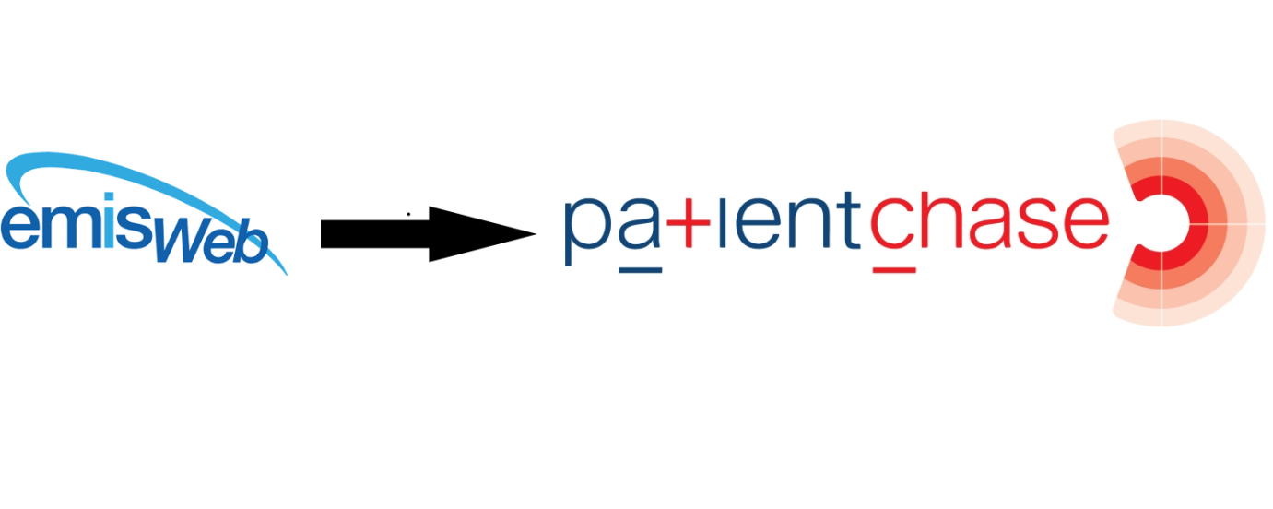

Step 1 –Importing the flu searches into EMIS.
The prebuilt search is found in our PatientChaseweb folder in the C: Drive>Program Data location.
It is bundled in with other searches in a file called PatientChaseSearches.xml
Go to Population Reporting, select a folder to import into or create a new one called PatientChase.
Then click Import, select the 3 dots to the right and navigate to C>Program Data>PatientChaseweb.
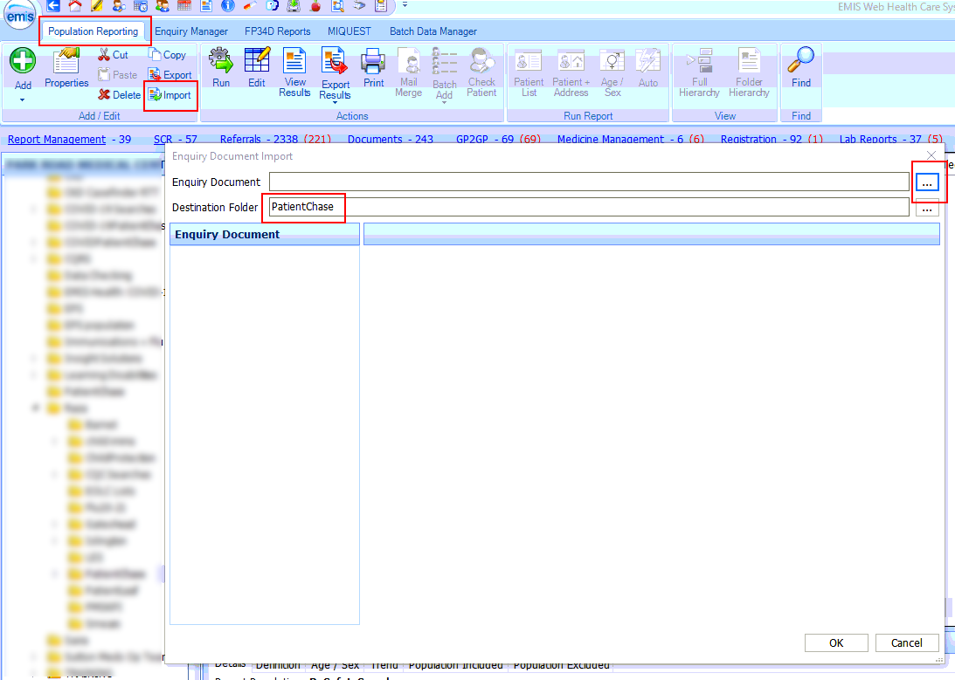

Within this folder select the file called PatientChaseSearches.xml. Click Open.
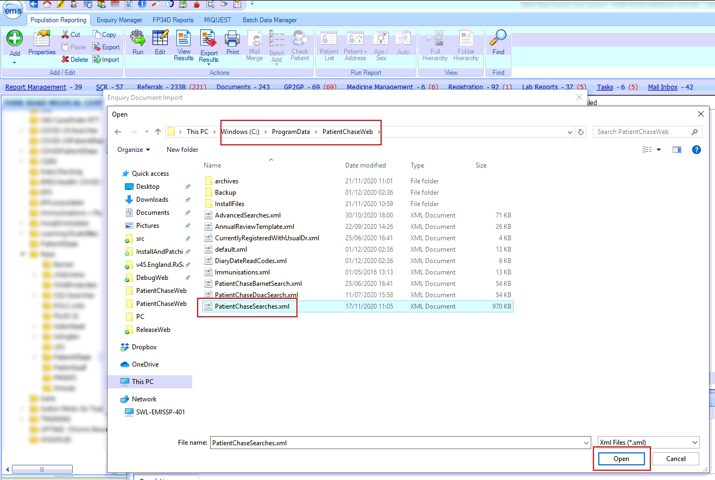
NB It is good practice to reimport PatientChaseSearches.xml from time to time to ensure that you are you using the latest version of the file.

Step 2 – Locate the flu search.
After you complete step 1 above you will be presented with a number of folders. Open the folder called PatientChaseSearches and locate the Auto Report called ‘All patients at risk who have not yet had Influenza Vac’.
Run the Auto Report.
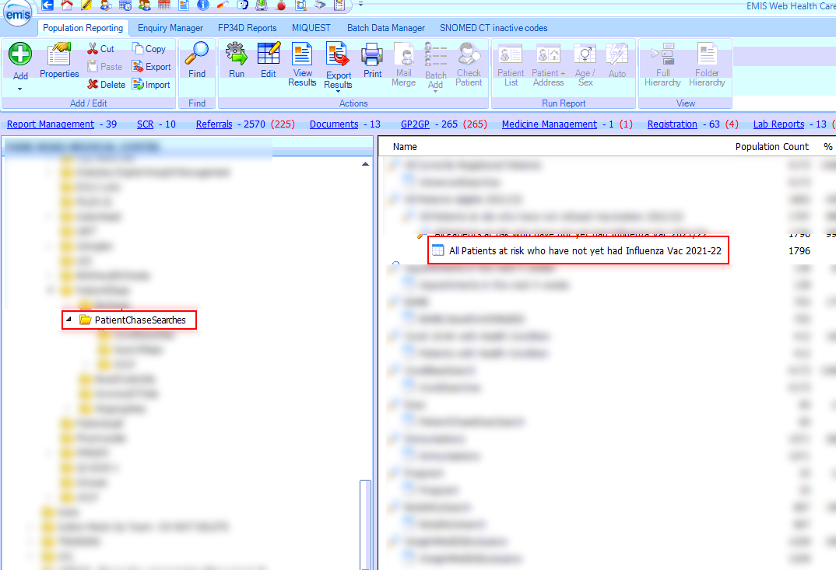

Step 3 - Exporting the results from EMIS.
Then click on View Results for the Auto Report.
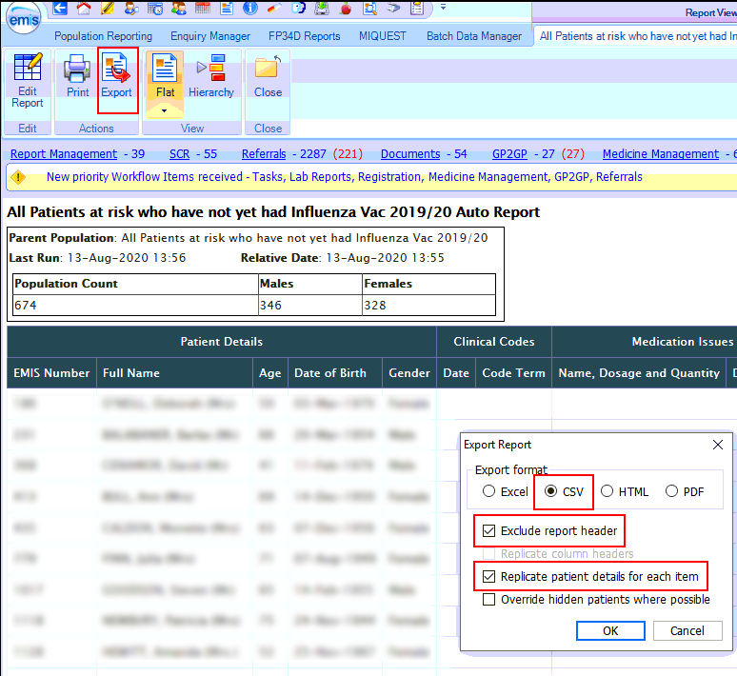
Click on Export then select the same export criteria as shown above.

Export to the desktop.
(NB. if you have previously created a folder where you export your EMIS searches to for synchronising with PatientChase then export to this location)
You can make the file name whatever you wish but it must have the word Influenza in the name.
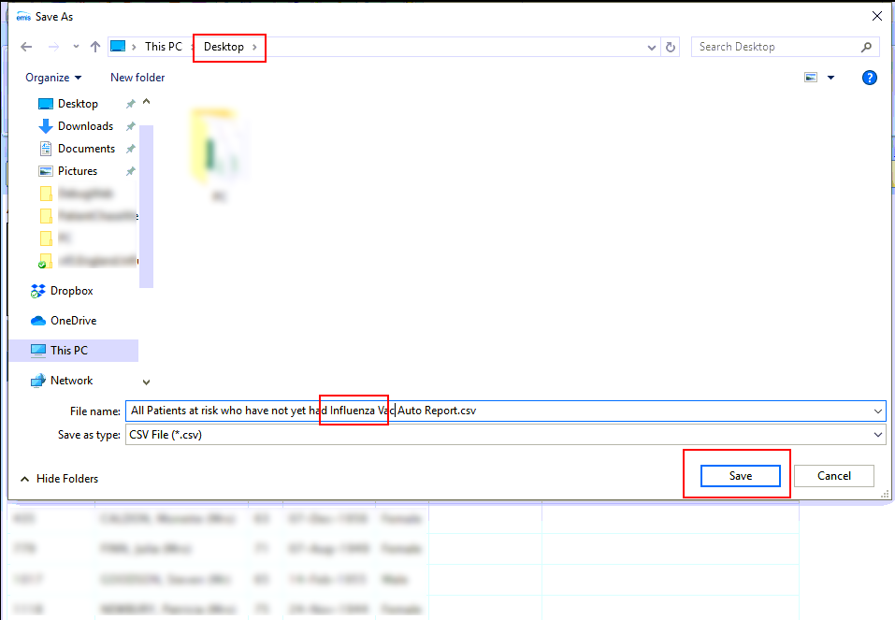
Note:
You must do this each new day you come to use flu data in PatientChase, whether you use the software daily, weekly or monthly.

Step 4 – Open PatientChase and synchronise the flu at risk data with PatientChase.

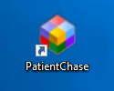
Make sure you are still logged into EMIS then double click the PatientChase icon on your desktop.

When PatientChase loads up, check first that you are running the latest version of PatientChase. This is indicated by a green tick near the top right of the screen:
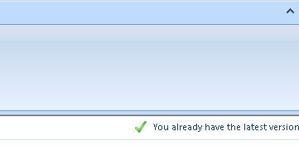
If you have a blue 'i' in place of the green tick, then restart PatientChase to load a patch update. From time to time we patch out updates and fixes so please look out for the green tick.
Next, click the EMIS Sync button.
When complete, PatientChase is loaded with your latest flu at risk data (as well as the default chronic disease data).
