Using PatientChase to identify patients who need a Covid vaccination in line with the government’s priority groups
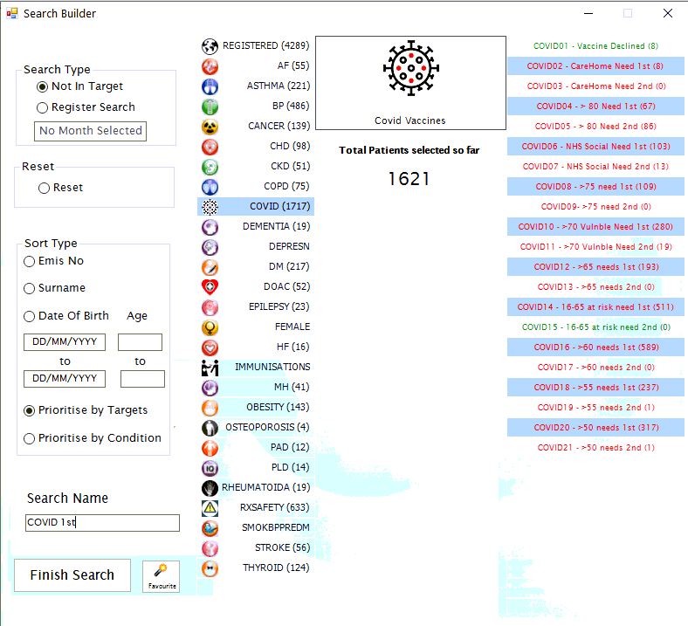
In this guide you will be shown how to:
- Import Covid vaccination priority groups as a suite of targets in the PatientChase Search Builder
- Identify patients who are eligible and have not had a 1st vaccination based on the government’s priority groups
- Identify patients who are eligible and have not had a 2nd vaccination based on the government’s priority groups
- Identify whether patients have an appointment

Introduction
It is now possible to use PatientChase to identify eligible patients who have not had a Covid vaccination in line with the government’s priority groups.
You can search for specific groups, merge groups together, identify who hasn’t an appt but should have and repeat for those who’ve had an initial jab but need the second jab.
This avoids the need to spend a lot of time cross-referencing patients when making appointments.

Examples of use
Instant cross-referencing of lists
By combining any of the priority groups, you can easily see whether patients appear in several groups, thereby removing the need to spend precious time identifying whether a patient appears in several priority groups, e.g. a 70 year old in a care home.
Identifying patients without an appointment
Using our appointment fields, quickly spot eligible patients who should but don’t have an appointment in a vaccination clinic.
You can do this for either 1st vaccinations or 2nd vaccinations and for any/all priority groups.
Reminders
Instantaneously identify patients who need to be sent a reminder when their 2nd vaccination is due.

Transferring Covid data from EMIS into PatientChase

Note:
You must do this each new day you come to use Covid data in PatientChase, whether you use the software daily, weekly or monthly.
Step 1 – Importing the prebuilt searches of Covid priority group patients into EMIS Population Reporting.
The prebuilt searches which identify patients who are eligible (and have not yet had) for Covid vaccinations is found in our PatientChaseWeb folder in the C: Drive>Program Data location.
It is bundled in with other searches in a file called PatientChaseSearches.xml
Go to Population Reporting, select a folder to import into or create a new one called PatientChase.
Then click Import, select the 3 dots to the right and navigate to C>Program Data>PatientChaseweb.
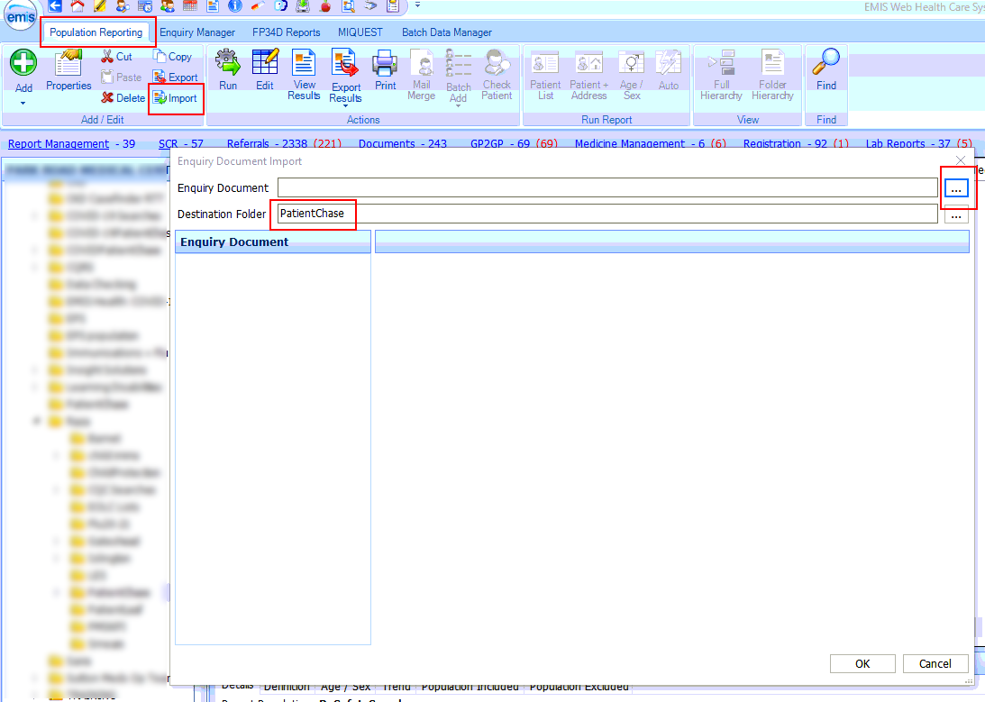
Within this folder select the file called PatientChaseSearches.xml. Click Open.
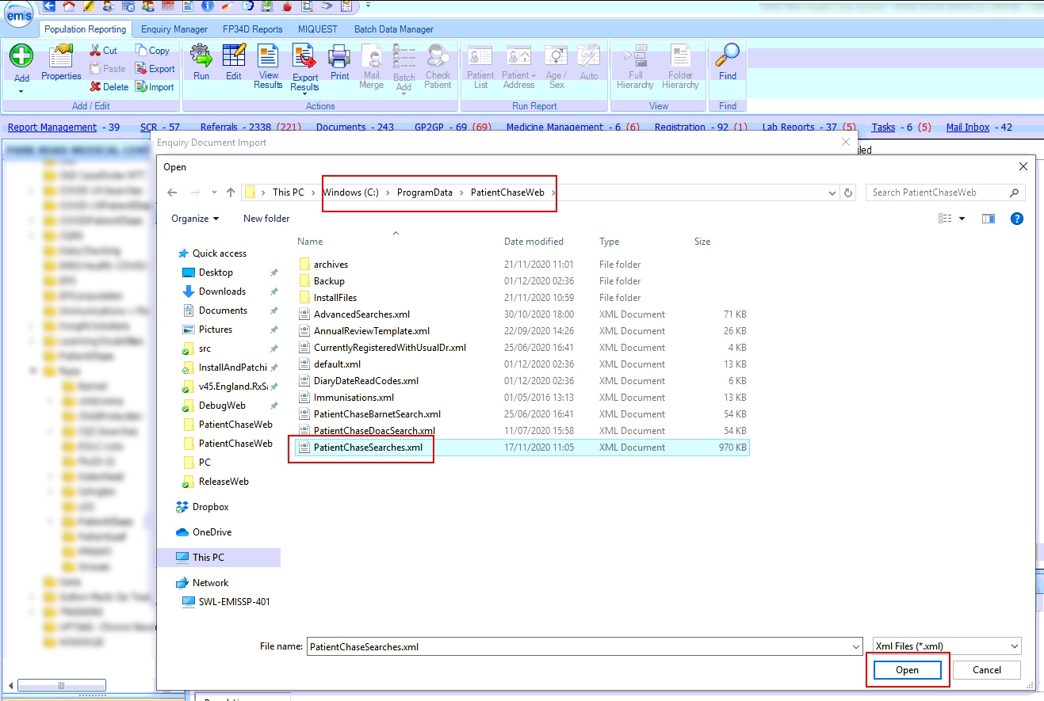

Step 2 – Run auto reports for the Covid searches.
Run an Auto Report for each of the four searches that make up the Covid suite of searches.
The suite comprises of the following 4 searches:
Appointments in next 4 weeks
Patients with Health Condition
CovidSearches
Pregnant
(These 4 combine later on in PatientChase)
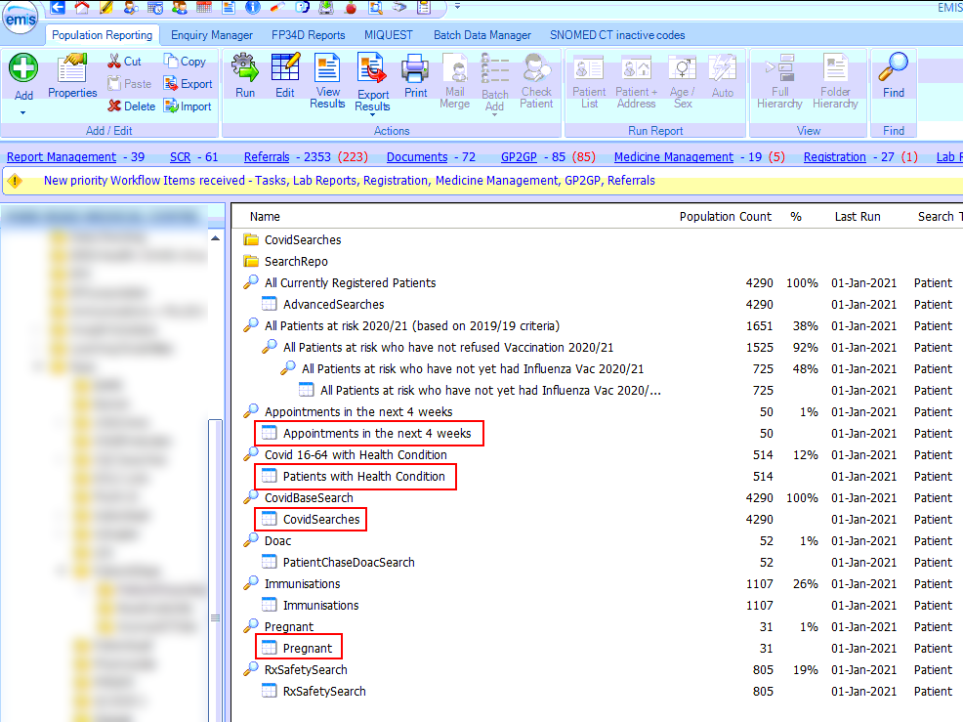

Step 3 – View results and export from EMIS.
Click on View Results then Export>csv>Exclude report header>Replicate patient details>OK>Desktop>Leave name of file as it appears>Save.
Do this for all four of the auto reports.
This is important.
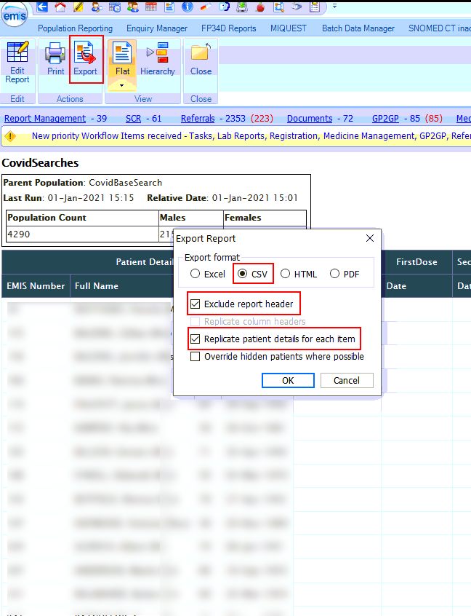
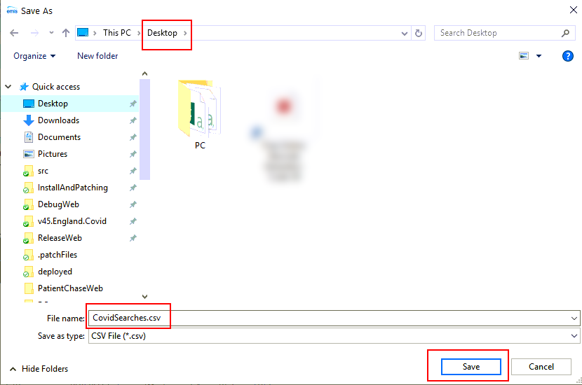
Once you have done this for all four auto reports you will see them as Excel files on your desktop.
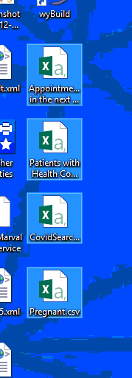

Step 4 – Open PatientChase and synchronise the Covid data with PatientChase.
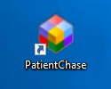
Make sure you are still logged into EMIS then double click the PatientChase icon on your desktop.

When PatientChase loads up, check first that you are running the latest version of PatientChase (version 60 and above). This is indicated by a green tick near the top right of the screen:
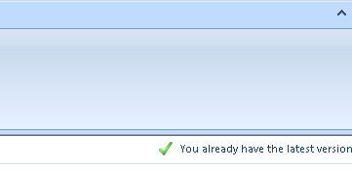
If you have a blue 'i' in place of the green tick, then restart PatientChase to load a patch update. From time to time we patch out updates and fixes so please look out for the green tick.
Next, click the EMIS Sync button.
When complete, PatientChase is loaded with your latest Covid data (as well as the default chronic disease data).

Identifying Covid priority group vaccination patients in PatientChase

Once the sync has completed, you can search for patients requiring a vaccination using the Search Builder.

Add>Not in Target>Hover over the COVID button. Notice all the priority groups listed to the right.

Click the COVID button to select ALL patients who need either a 1st or 2nd vaccination. Click Finish Search.
Or:
Hover over the COVID button and move the mouse directly right and select any combination of priority groups. In the example below all patients who have not yet had a 1st vaccination are selected.

Viewing patients who need a vaccine

The results will show which patients need a vaccination and which priority groups they each fall within. Contact them in the usual manner.
In the example below the top patient in the list is highlighted and shows that they are in 5 of the priority groups.
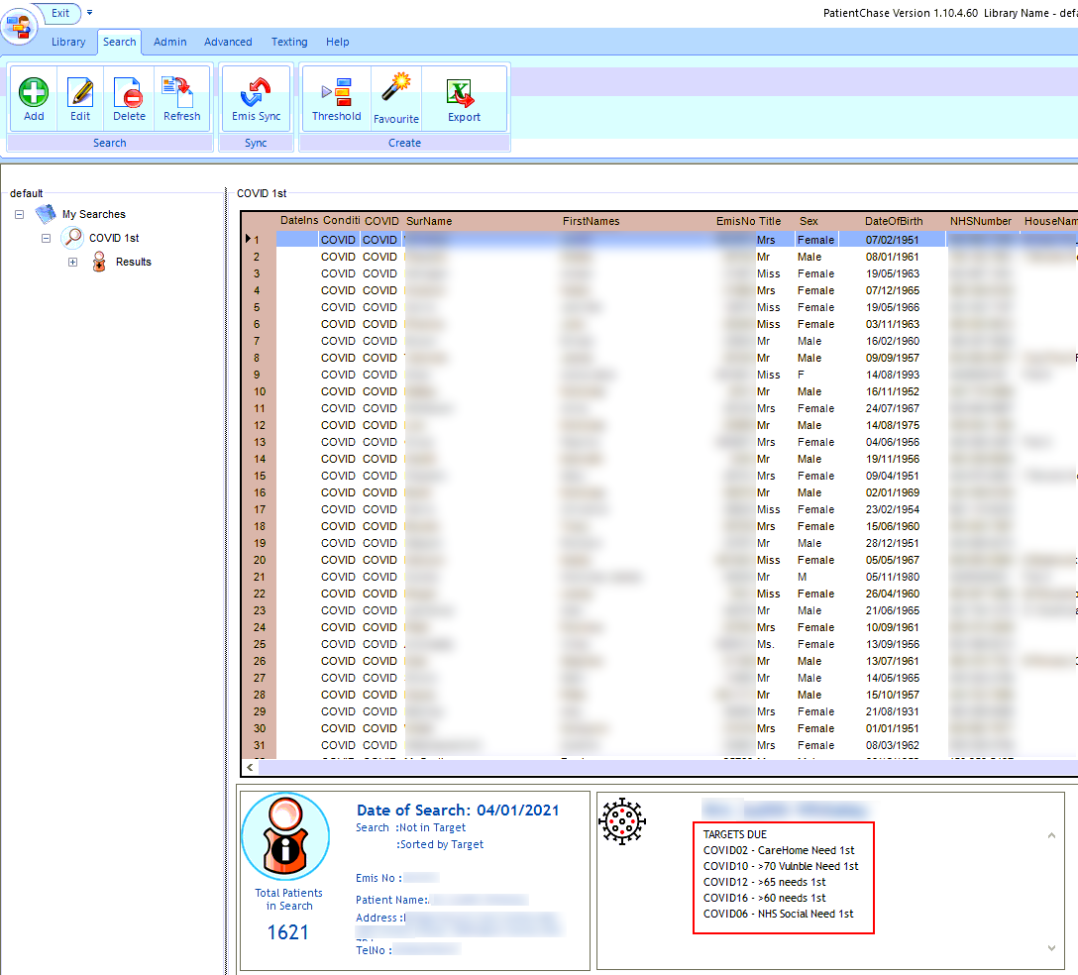

Checking whether patients have an appointment for a 1st or 2nd vaccination

Having imported the Auto Report for appointments (Steps 2 and 3), the Covid search results have additional columns indicating whether a patient has or hasn’t an appointment and the reason for that appointment (make sure when booking patients in EMIS you give a reason. Appointment Book>Book Slot>Reason).

These appointment columns can be found by scrolling across the results list in PatientChase. Click on the AptDate header to sort your list. Notice below those patients who have an appointment booked and those where the entry is blank indicating the patient does not have an appointment. If the Reason is blank then you should know by the date whether this is a Covid clinic. Select and contact patients in the usual manner.

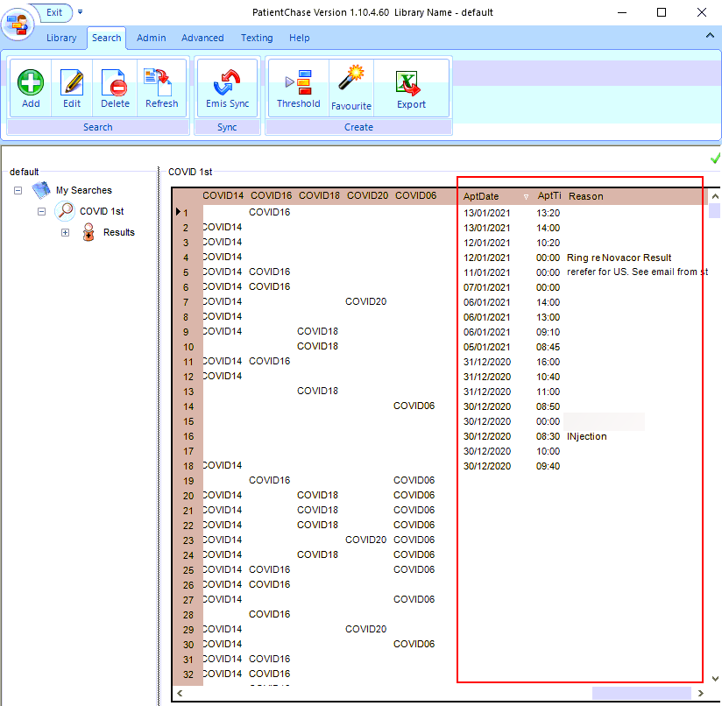
Exporting results to Excel
You may wish to print out or share your Covid search results with others in the surgery, for example receptionists who can make bookings for those identified by PatientChase as appearing across several priority groups and/or who do not have an appointment.
Right click on the name of your search>Export Search to Excel.
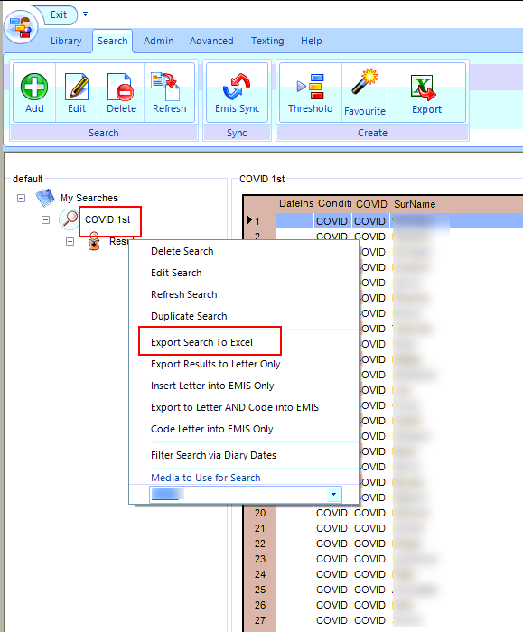

The spreadsheet will also display which priority groups apply to each patient and whether they have an appointment.
