Using PatientChase to target patients needing medication reviews
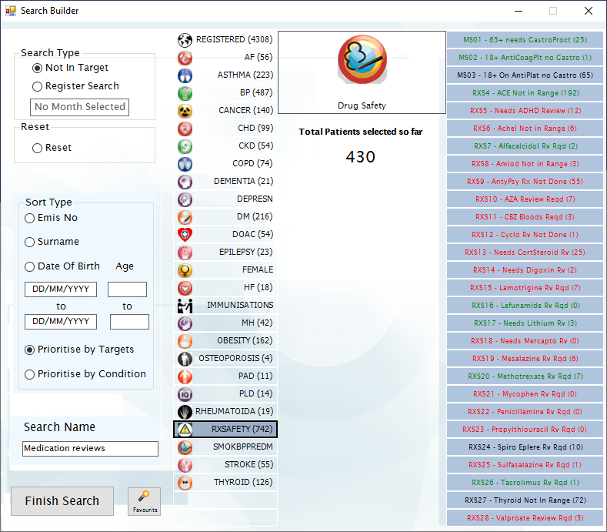

In this guide you will be shown how to:
- Import the most common medications as targets into the PatientChase Search Builder
- Search for patients who need a review for any combination of these medications

Introduction
It is now possible to use PatientChase to target patients who are showing in EMIS as needing a review of their medications.
Pick a specific medication or pick a combination of medications. Naturally PatientChase will produce patient-centric results, meaning you will be presented with the medication reviews that apply to each patient. You can then target the patient once and review all their medications at the same time.
The same way you would use PatientChase to target patients for multiple chronic diseases.

Medications included and specifications
You are able to search for patients who need a review of the following medications:

ACE | ARB | Mercaptopurine
AcetylChol Inhibitors | Mesalazine
ADHD Medication | Methotrexate
Alfacalcidol | Mycophenolate
Amiodarone | Penicillamine
Antipsychotics | Propylthiouracil
Azathioprine | Spironalactone & Eplerenone
Carbimazole | Sulfasalazine
Cyclosporin | Tacrolimus
Corticosteroids | Thyroxine
Digoxin | Valproate
Gout Rx | MS01 Nsaids >65
Lamotrigine | MS02 Anticoagulants
Leflunamide | MS03 Nsaids > 18
Lithium

Please refer to the document entitled DrugMonitoringforAdultsinPrimaryCare.pdf for their specifications including the default time period when the medication is due for review.

Please contact us should you wish to change the frequency at any point.

Examples of use
Stand-alone medication searches
Build searches for patients who need a review of any combination of medications. Then also review their corresponding conditions when you make contact with the patient.
Combining month of birth searches with medications reviews
Build month of searches and combine them with the medication targets to identify patients who are born in a certain month, have not had a review for their chronic diseases AND who need a review for certain medications.
Combining QOF searches with medication reviews
Build QOF searches and combine them with the medication targets to identify patients who are missing QOF targets for specific conditions AND who need a review for certain medications.

Transferring medication review data from EMIS into PatientChase

Note:
You must do this each new day you come to use medication data in PatientChase, whether you use the software daily, weekly or monthly.

Step 1 – Importing the prebuilt search of medication review patients into EMIS.
The prebuilt search (called RxSafetySearch) which identifies patients who need a medication review is found in our PatientChaseWeb folder in the C: Drive>Program Data location.
It is bundled in with other searches in a file called PatientChaseSearches.xml
Go to Population Reporting, select a folder to import into or create a new one called PatientChase.
Then click Import, select the 3 dots to the right and navigate to C>Program Data>PatientChaseweb.
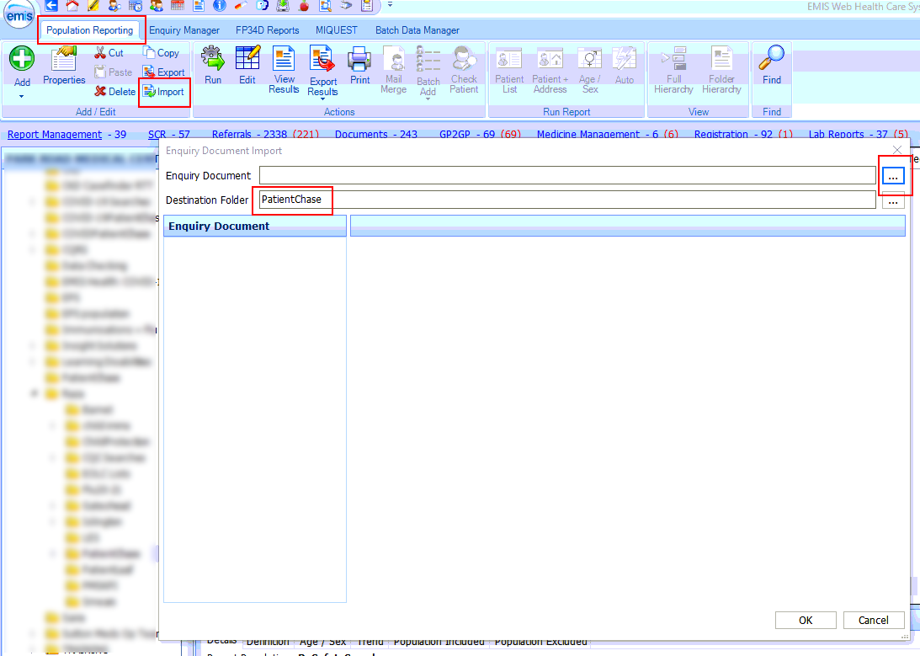

Within this folder select the file called PatientChaseSearches.xml. Click Open.
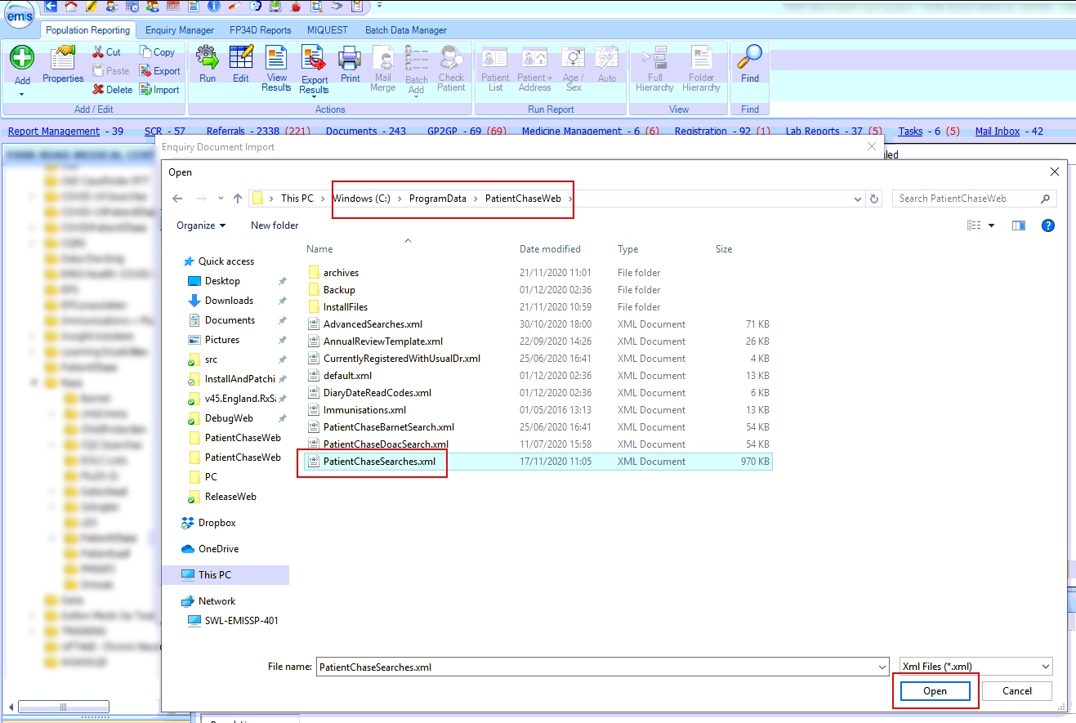
Step 2 – Run an auto report.
Next, run the Auto Report called RxSafetySearch.
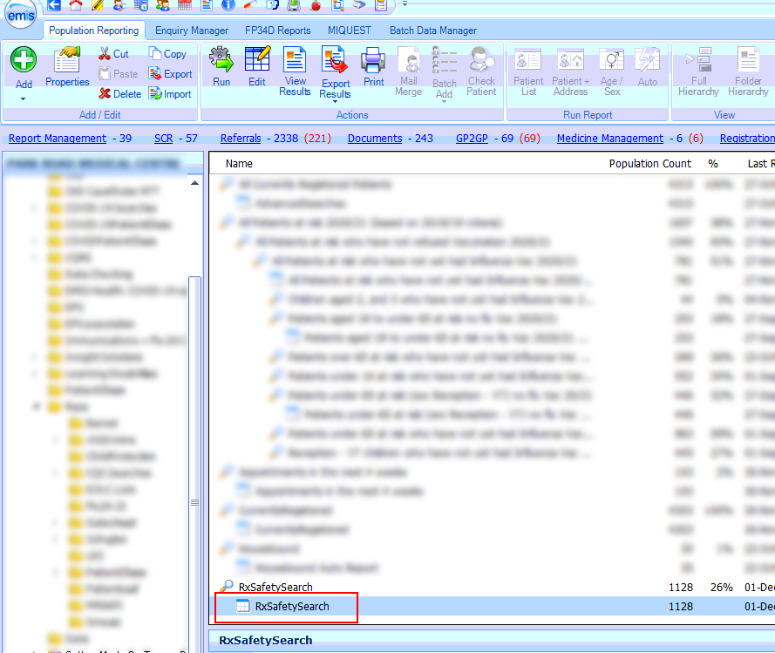
Step 3 – View results and export from EMIS.
Click on View Results then Export>csv>Exclude report header>Replicate patient details>OK>Desktop>Leave name of file as it appears>Save.
This is important.
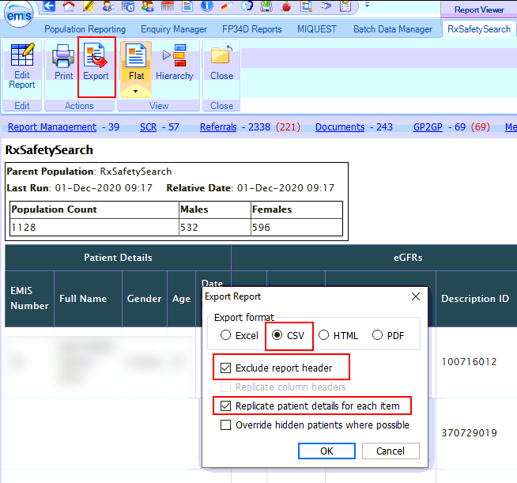
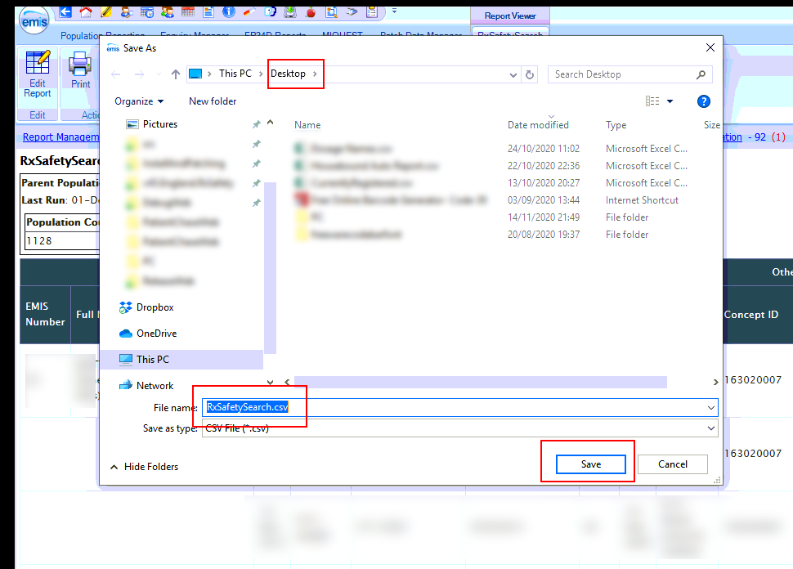
Step 4 – Open PatientChase and synchronise the medication review data with PatientChase.
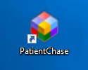
Make sure you are still logged into EMIS then double click the PatientChase icon on your desktop.

When PatientChase loads up, check first that you are running the latest version of PatientChase. This is indicated by a green tick near the top right of the screen:
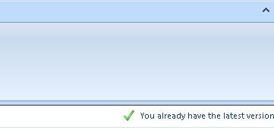
If you have a blue 'i' in place of the green tick, then restart PatientChase to load a patch update. From time to time we patch out updates and fixes so please look out for the green tick.
Next, click the EMIS Sync button.
When complete, PatientChase is loaded with your latest medication review data (as well as the default chronic disease data).
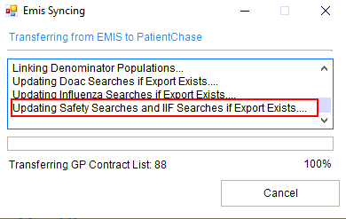

Identifying medication review patients in PatientChase

Once the sync has completed, you can search for patients requiring medication reviews using the Search Builder.

Add>Not in Target>Hover over the RXSAFETY button. Notice all the medications listed to the right.

Click the RXSAFETY button to select ALL the medications that need reviewing. Click Finish Search.

Or:
Hover over the RXSAFETY button and move the mouse directly right and select any combination of medications that need reviewing.

Viewing patients who need their medication/s reviewed

The results will show which medications each patient needs a review for. Contact them in the usual manner.
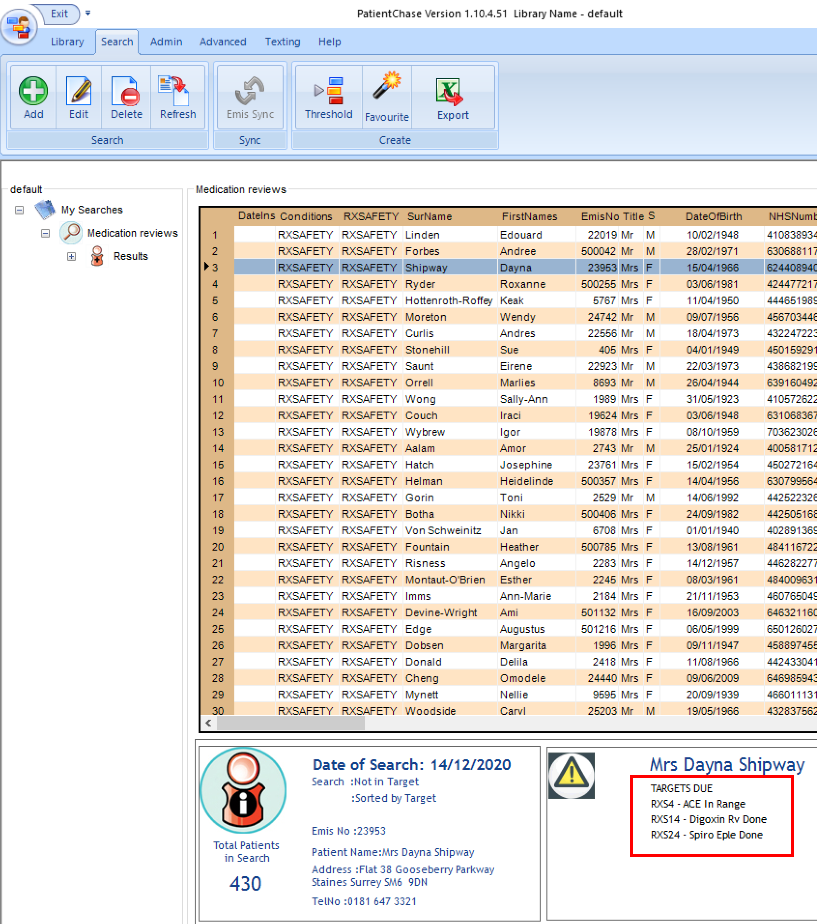

Sharing the results with a clinician for review prior to contact

Should you wish to share with a clinician in the practice, e.g. a pharmacist, the list of patients who need a medication review and the reasons for them being identified, then right click on the name of the search and select ‘Export Search to Excel’.

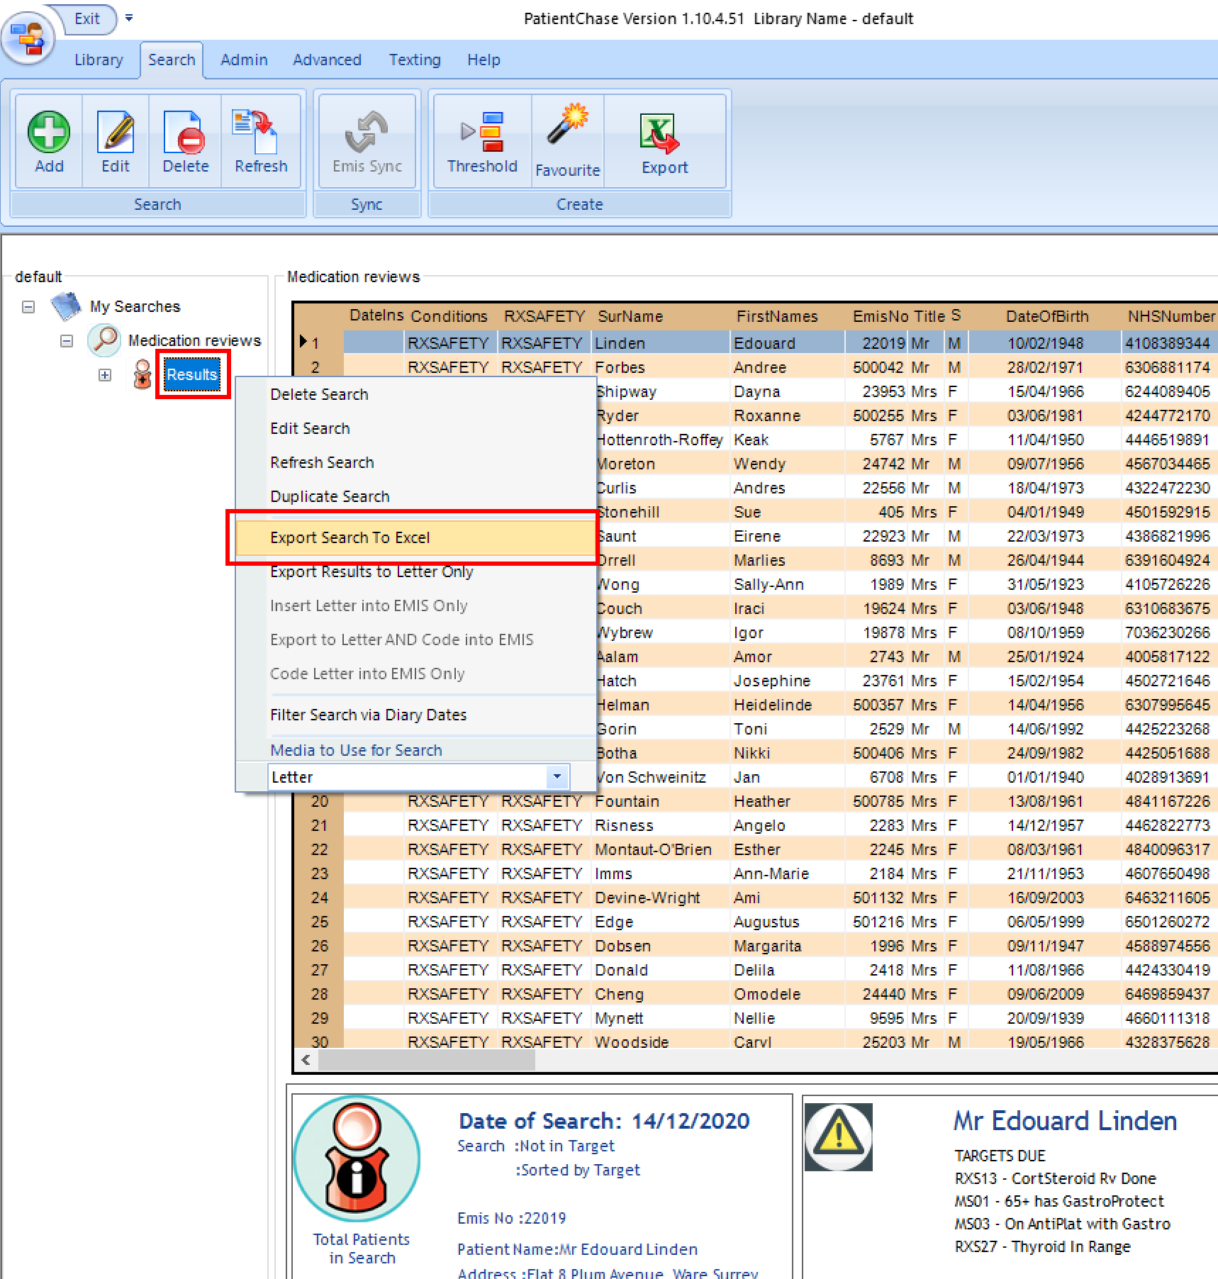

Excel then opens for you to share the document with the appropriate clinician.
