Using PatientChase to risk stratify patients
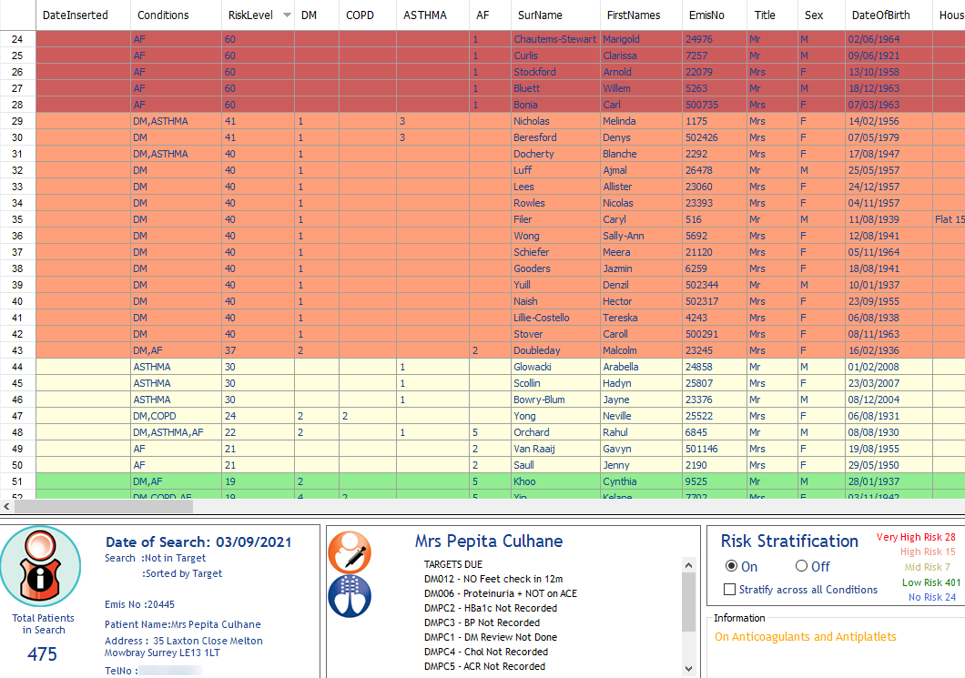

In this guide you will be shown how to:
- Import risk stratification data into PatientChase
- Identify patients from very high risk to no risk based on UCL Partners criteria

Introduction
We have incorporated the tools supplied by UCL Partners (https://uclpartners.com/proactive-care/) to enable risk stratification of your patients directly through PatientChase.
Using our co-morbidy approach, we have added a new dimension to risk stratification by taking into account all the conditions a patient may have, even where you may have not included those conditions in your search.
For example, a diabetic patient may be risk stratified as low risk in diabetes alone, but higher risk if they have 1 or more other conditions.
PatientChase will colour code patients based on their level of risk and as such these patients can be targeted differently, beit with the information they are sent or the clinician they are directed to.
This will not only ensure they receive the right level of care, but also prevent any inappropriate workload being directed to GPs.

Transferring risk stratification data from EMIS into PatientChase

Step 1 – Importing the prebuilt risk stratification searches into EMIS.
The prebuilt searches are found in our PatientChaseweb folder in the C: Drive>Program Data location.
It is bundled in with other searches in a file called PatientChaseSearches.xml
Go to Population Reporting, select a folder to import into or create a new one called PatientChase.
Then click Import, select the 3 dots to the right and navigate to C>Program Data>PatientChaseweb.
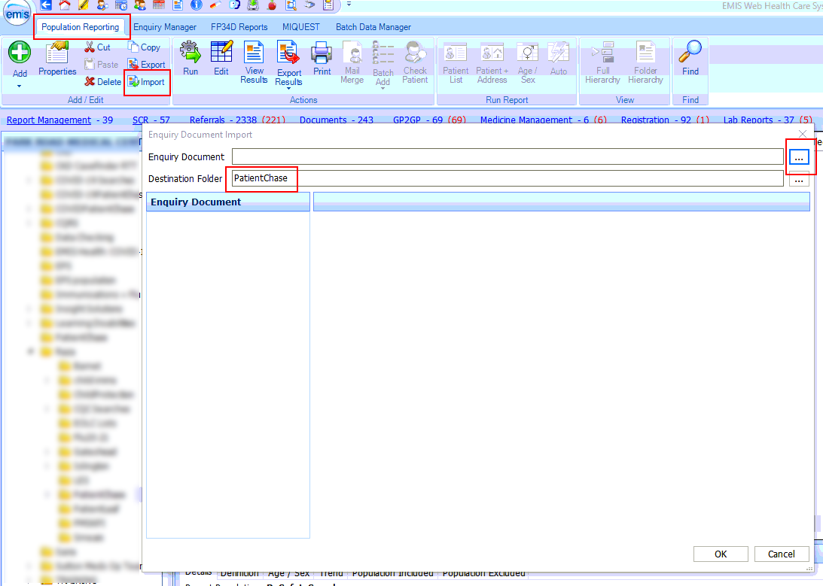

Within this folder select the file called PatientChaseSearches.xml. Click Open.
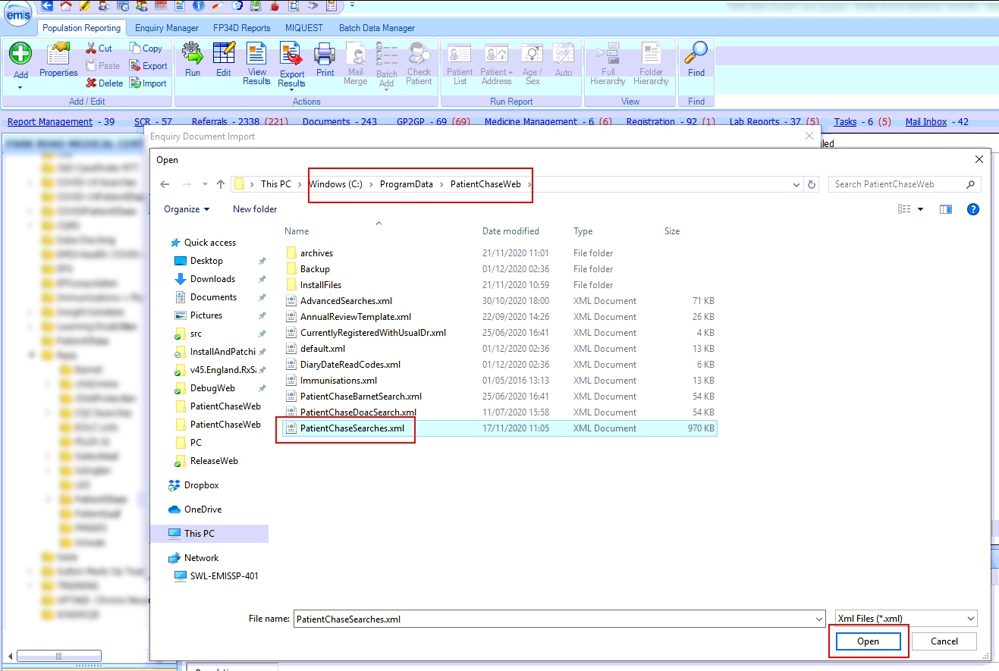

Step 2 – Locate the risk stratification searches.
After you complete step 1 above you will be presented with a number of folders:
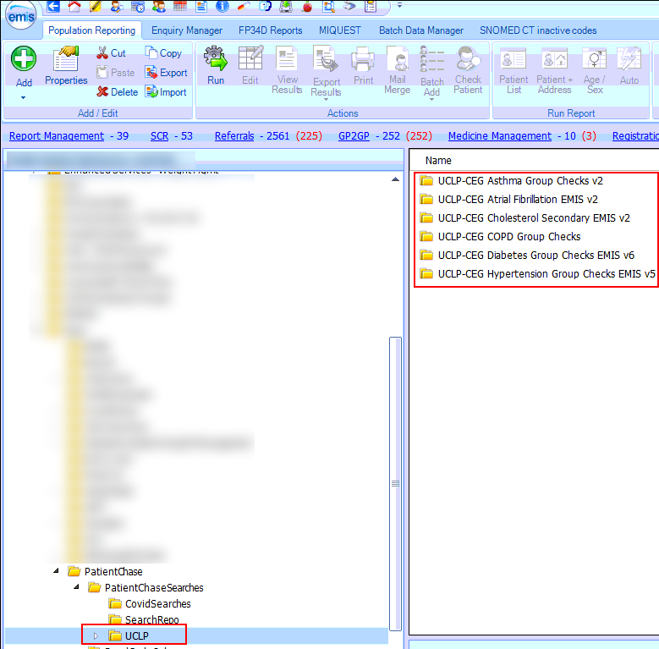
Locate the folder UCLP. This folder stores the risk stratification searches compiled by UCLP which PatientChase will use.

Step 3 – Run all the searches within the UCLP folder.
Right click on the UCLP folder and click Run. This will run all the searches in the UCLP sub folders at once.
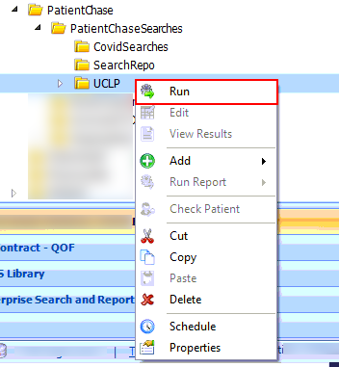

Step 4 – View and export the searches from EMIS
Important:
There are a number of searches within each of the UCLP sub folders. The auto reports for each must be individually exported onto the desktop prior to loading into PatientChase.
As there are a lot of these reports, it is strongly advised to create a PatientChase folder on the desktop (or a preferred location) otherwise your desktop will become cluttered.
Once you have created a folder called PatientChase on your desktop, you must set PatientChase to point to this location.
To do this, go to Advanced>Options>Location and type in the name of the PatientChase folder exactly how you named it. See below.
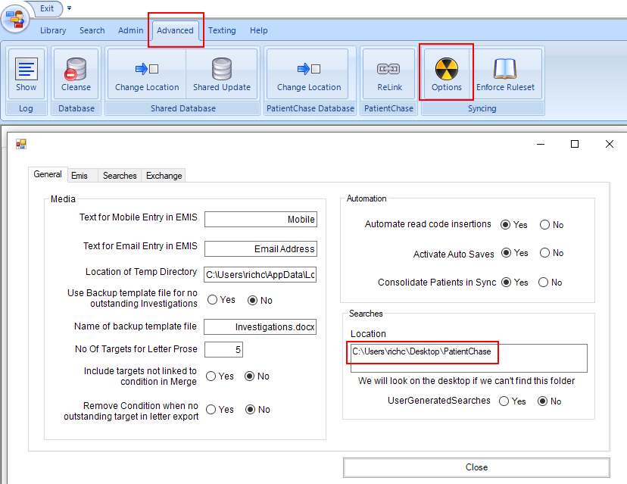
This will affect the location of all other searches you synchronise manually between EMIS and PatientChase (for example Advanced Searches, COVID searches, RX Safety searches).
They can all be placed in the same folder however.
If you have already created such a folder for storing other searches (for example Advanced Searches, COVID searches, RX Safety searches) then you do not need to create a new folder nor change the location and should export the Risk Strat searches to this same location.

Once you have created a folder on your desktop (or a preferred location) to export to, follow this process for every auto report in each sub folder.
Step 4a – View Results of the Auto Report
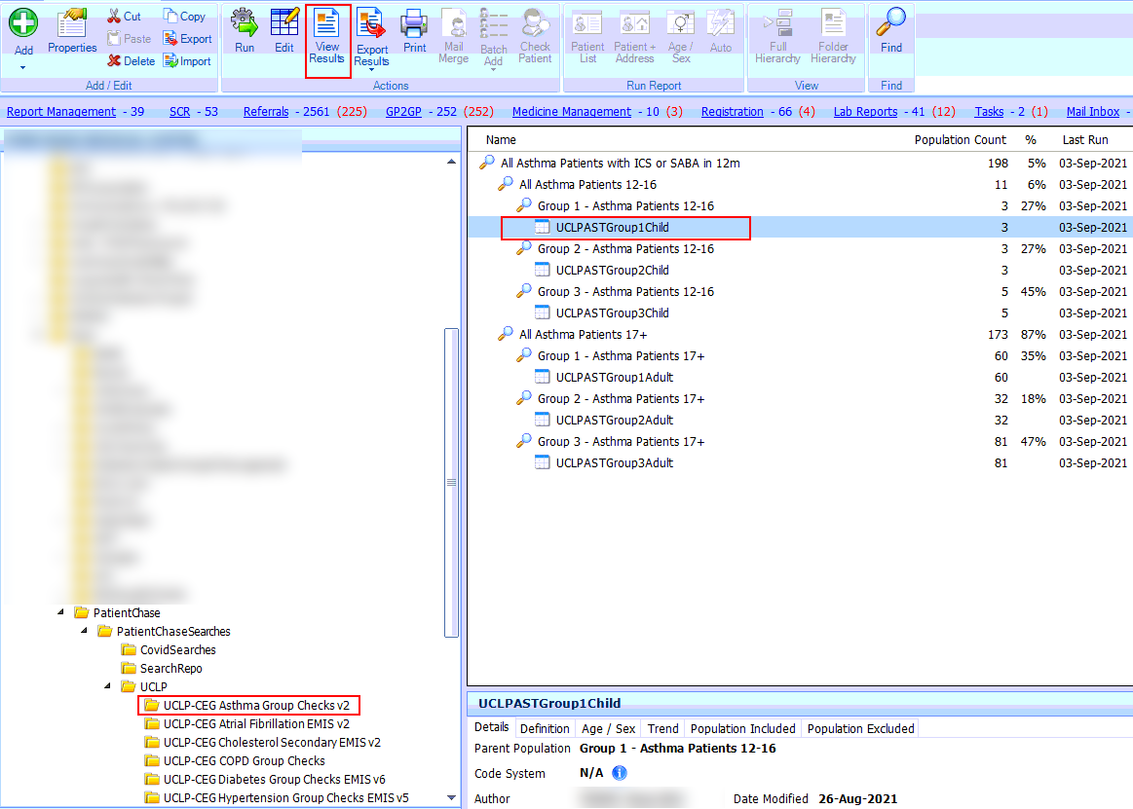

Step 4b – Export the Auto Report
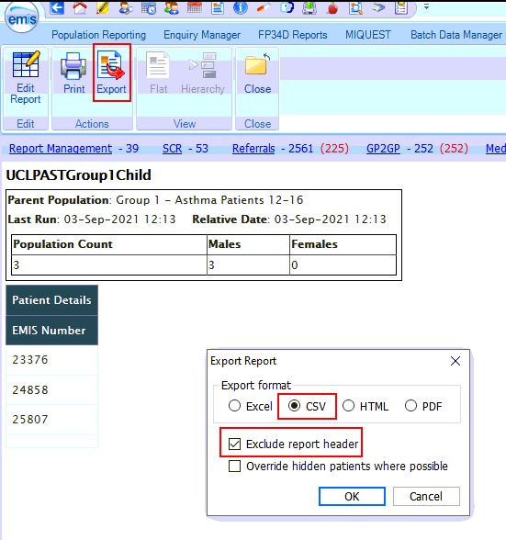

Step 4c – Export the Auto Report
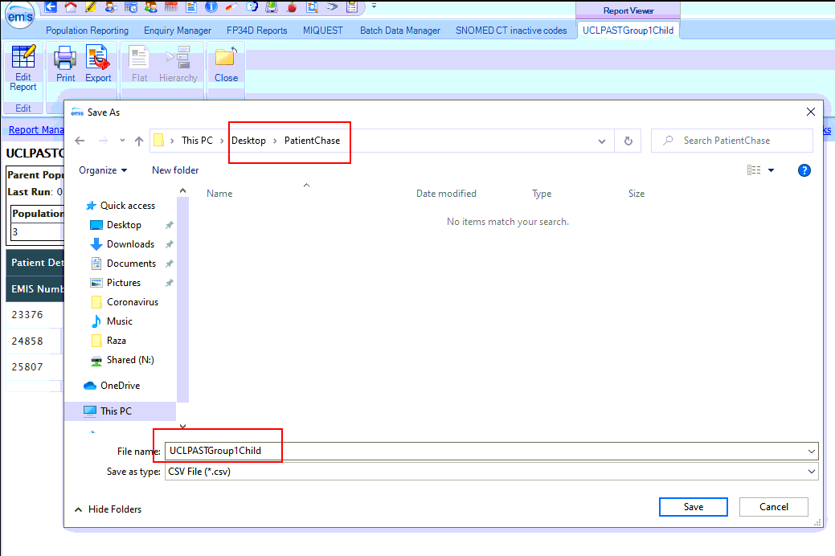
Locate the folder and export each Auto Report there. Do not change the name of the file.

Step 5 - EMIS Sync
Once you have exported all the Auto Reports to the folder, Click the EMIS Sync button in PatientChase. This will import the Risk Strat data.
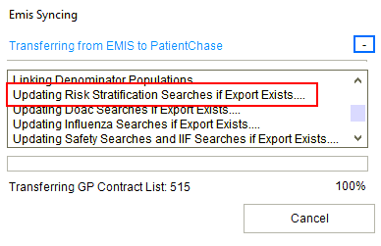
Note:
You must perform Steps 3 to 5 each new day you come to use risk stratification data in PatientChase, whether you use the software daily, weekly or monthly.

Step 6 – Viewing the results
Create your chronic disease search as normal.
Should you now wish to overlay the Risk Strat data, click the Risk Stratification button to On.
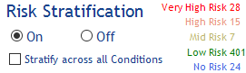
The patients in your search will then colour code depending upon their level of risk within the condition or conditions listed in your search.
You can now export the list in the usual manner for review by a clinician.
Alternatively, you can select patients within their colour bands and contact them with specific comms dependent upon their level of risk.

Risk Stratifying patients across all their underlying conditions
Should you wish to risk stratify patients across ALL their underlying conditions, in other words including any conditions they may have that do not form part of your search, then click the Stratify across all Conditions box.
