Updating PatientChaseSearches.xml
In this section you will be shown how to:
- Re-import the PatientChaseSearches.xml file

PatientChaseSearches.xml stores a suite of searches (Auto Reports) used by PatientChase, some of which you may use.
It is advisable that whenever we patch out a new version/update of PatientChase you re-import PatientChaseSearches.xml and then use the updated Auto Report within that which is relevant to you.
For example, we may update the criteria that form AdvancedSearches.xml which determines whether PatientChase filters out patients that have had a chronic disease review (based on your practice’s ‘review done’ codes).
It is important that you follow these instructions to ensure your data is accurate.

Only follow these instructions if you export searches from EMIS prior to syncing PatientChase with EMIS. If you simply ‘EMIS Sync’ PatientChase with EMIS when you open it, then ignore this guide.

Step 1 – Delete old searches or the folder PatientChaseSearches
In the first instance it is necessary to delete these out of date searches from Population Reporting.

Step 2 - Re-importing PatientChaseSearches.xml into EMIS
Go to Population Reporting, select a folder to import into or create a new one called PatientChase.
Then click Import, select the 3 dots to the right and navigate to C>Program Data>PatientChaseweb.
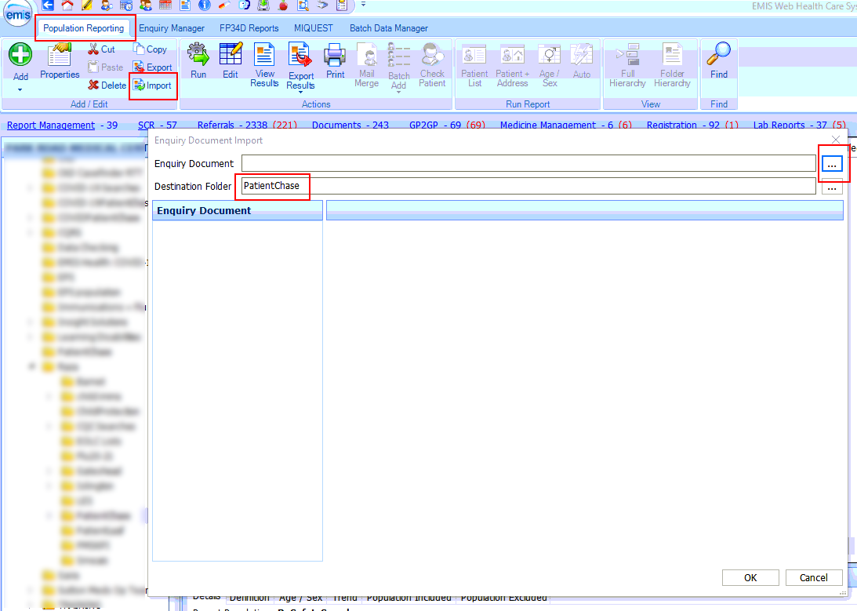

Within this folder select the file called PatientChaseSearches.xml. Click Open.
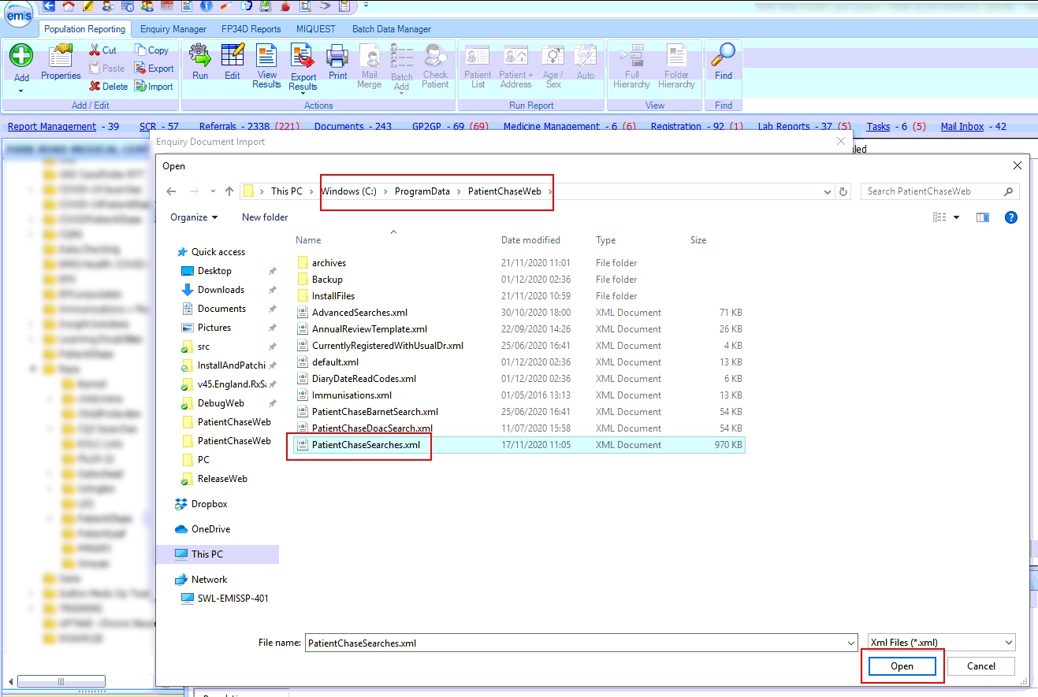

Step 3 – Locate the search/s (Auto Report/s) relevant to you
After you complete step 2 above you will be presented with a number of folders. Open the folder called PatientChaseSearches and locate the Auto Report/s relevant to you.
Run the Auto Report/s.

Step 4 - Exporting the results from EMIS.
Then click on View Results for the Auto Report/s relevant to you.
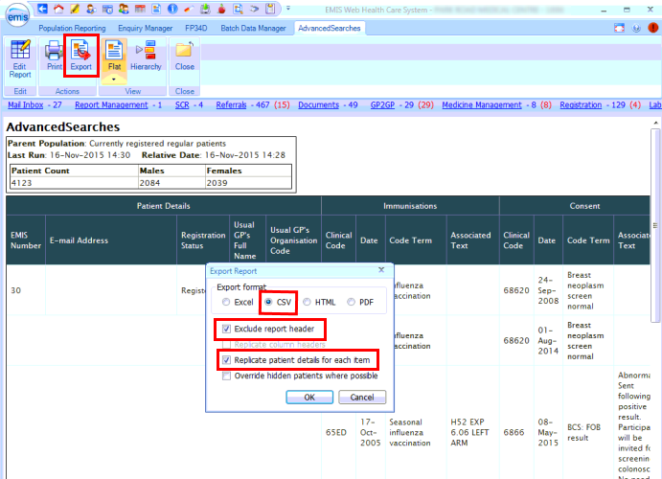
Click on Export then select the same export criteria as shown above.

Export to the desktop.
(NB. if you have previously created a folder where you export your EMIS searches to for synchronising with PatientChase then export to this location)
Do not change the name of the Auto Report.
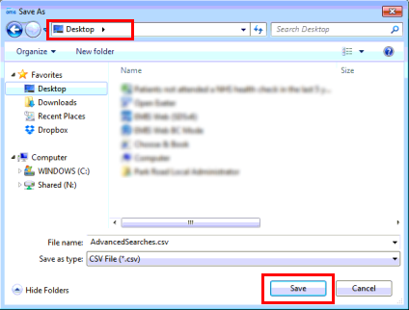
Repeat Step 4 for all Auto Reports relevant to your search criteria.

Step 5 – Open PatientChase and Click EMIS Sync.

