Using PatientChase to manage Weight Management DES patients
In this section you will be shown how to:
- Import Weight Management patient data from EMIS into PatientChase to ensure you have the very latest list of patients
- Run a Weight Management search of patients who need referral to your local Weight Management Service
- Combine Weight Management data with your BAME register (this is optional but may be important to your local surgery as the BMI index often needs to be differentiated between BAME and non BAME patients)

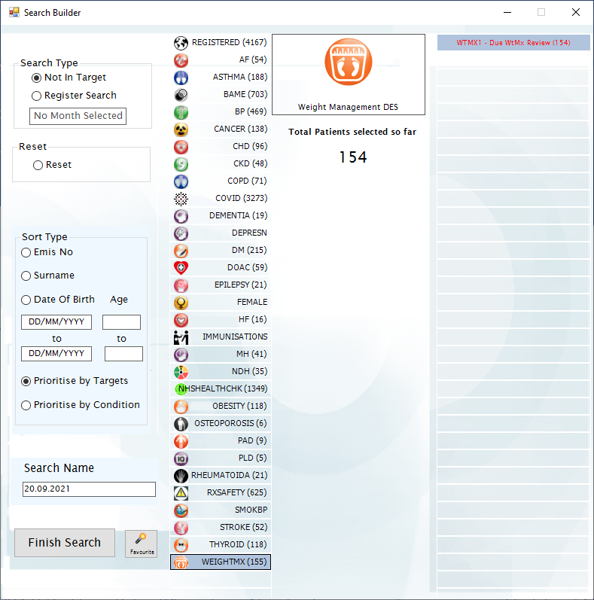

Step 1 – Importing the prebuilt Weight Management, BAME, Pregnant and Advanced Searches into EMIS.
These 4 searches are necessary to populate PatientChase.
The 4 prebuilt searches are found in our PatientChaseweb folder in the C: Drive>Program Data location.
They are bundled in with other searches in a file called PatientChaseSearches.xml
Go to Population Reporting, select a folder to import into or create a new one called PatientChase.
Then click Import, select the 3 dots to the right and navigate to C>Program Data>PatientChaseweb.
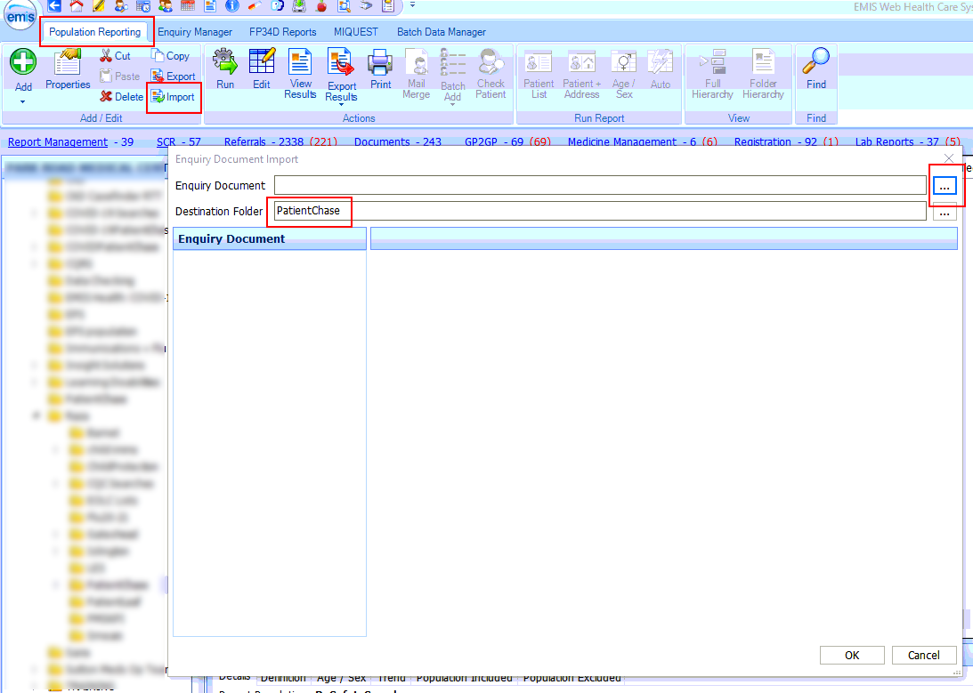

Within this folder select the file called PatientChaseSearches.xml. Click Open.
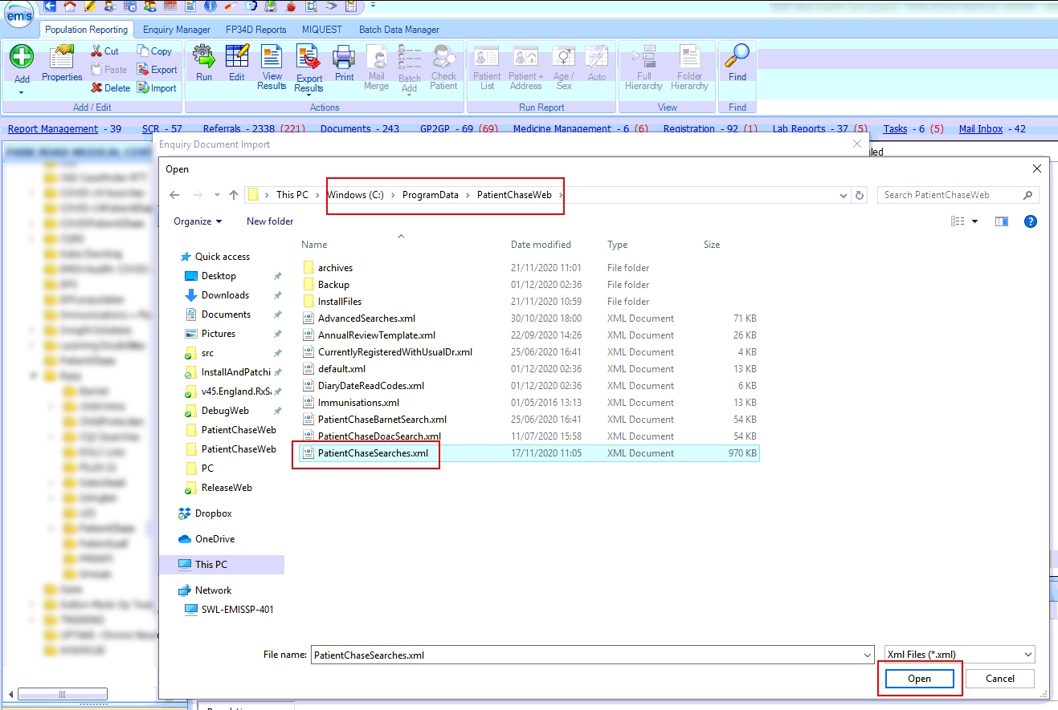
NB It is good practice to reimport PatientChaseSearches.xml from time to time to ensure that you are you using the latest version of the file.
Step 2 – Locate the prebuilt Weight Management, BAME, Pregnant and Advanced Searches.
After you complete step 1 above you will be presented with a number of folders. Open the folder called PatientChaseSearches and locate the Auto Report called ‘Advanced Searches’.
Run the Auto Report.
Repeat for the BAME, Pregnant and WeightMxDES Auto Reports.
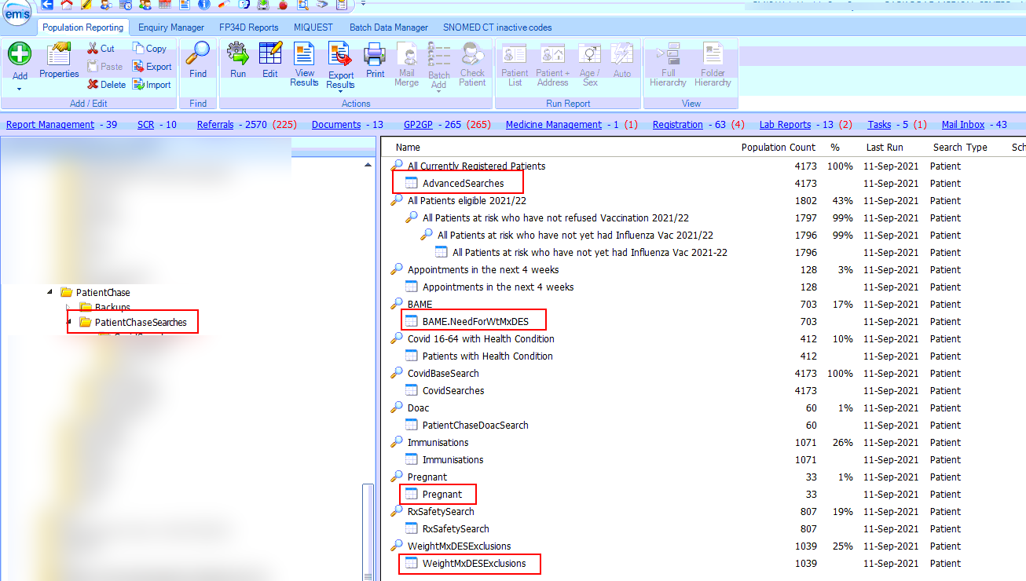

Step 3 - Exporting the results from EMIS.
Then click on View Results for the Advanced Searches Auto Report.
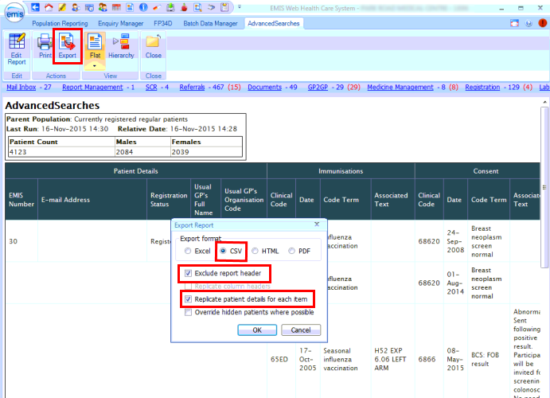
Click on Export then select the same export criteria as shown above.

Export to the desktop.
(NB. if you have previously created a folder where you export your EMIS searches to for synchronising with PatientChase then export to this location)
Do not change the name of the Auto Report.
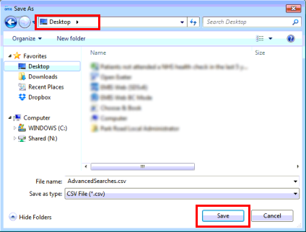
Repeat Step 3 for the BAME, Pregnant and WeightMxDES Auto Reports.

Step 4 – Open PatientChase and synchronise the data with PatientChase.

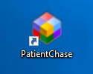
Make sure you are still logged into EMIS then double click the PatientChase icon on your desktop.

When PatientChase loads up, check first that you are running the latest version of PatientChase. This is indicated by a green tick near the top right of the screen:
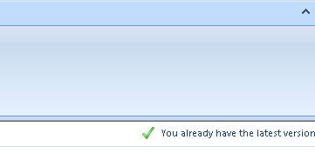
If you have a blue 'i' in place of the green tick, then restart PatientChase to load a patch update. From time to time we patch out updates and fixes so please look out for the green tick.
Next, click the EMIS Sync button.
When complete, PatientChase is loaded with your latest Weight Management and BAME data (as well as the default chronic disease data).
Note:
You must perform Steps 2 to 4 each new day you come to use weight management data in PatientChase, whether you use the software daily, weekly or monthly.
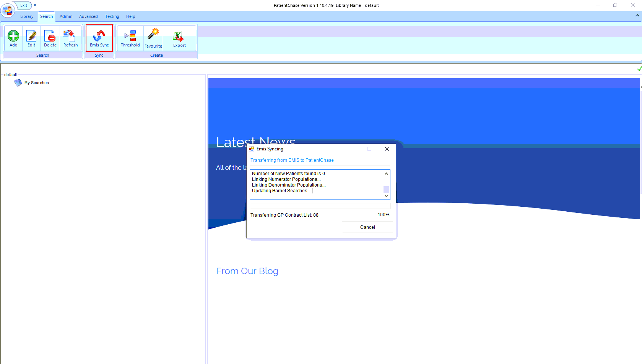

Examples of use
Example 1 – Building a search of patients who are due a weight management review based on the Weight Management DES.
Click Add>Not in Target>WEIGHTMX>Name Search>Finish Search
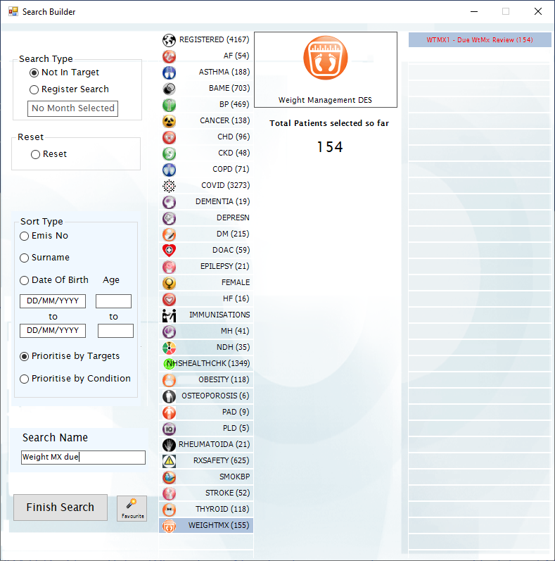
This will give you a list of those patients who are due a weight management review based on the Weight Management DES.
Refer these patients to your local weight management service.
Coding into EMIS – Go to Admin>Edit>Codes and enter alongside WTMX1 - Had WtMx Review the code you would like to use to batch code into the patient records.
Finally, use PatientChase to batch code these patients into EMIS.
Example 2 - Building a search of patients who are BAME and due a weight management review based on the Weight Management DES.
Step 1 - Click Add>Register Search>Select both BAME and WEIGHTMX registers> Name Search>Finish Search
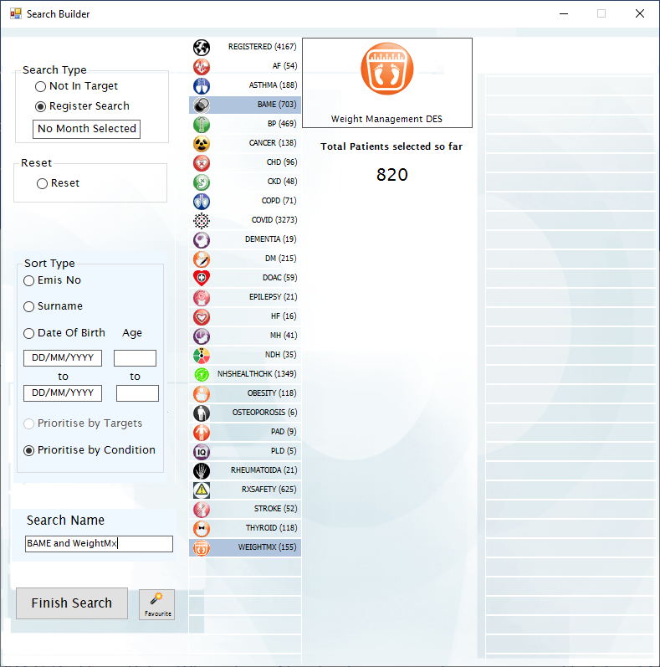
Step 2 - Create the search in Example 1 - Click Add>Not in Target>WEIGHTMX>Name Search>Finish Search

Step 3 – Merge the two searches together
Do this by dragging the name of your BAME and WeightMx combined register search into the name you gave for the Weight Management Review ‘Not in Target’ search.
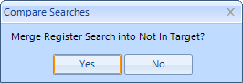
Click Yes when this message pops up.
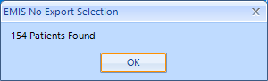
Click OK when this message pops up.
With the patients still highlighted in blue, RIGHT CLICK over the selection and click ‘Delete Unselected Patients’.
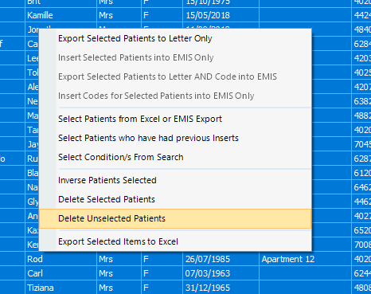
This removes all the patients that are not due a Weight Management review.

You will notice that the patients who need a medication review AND who are BAME are listed at the top:
