Using PatientChase to target NHS Health Check patients
In this section you will be shown how to:
- Import NHS Health Check patient data from EMIS into PatientChase to ensure you have the very latest list of patients
- Run a search of patients who need a health check

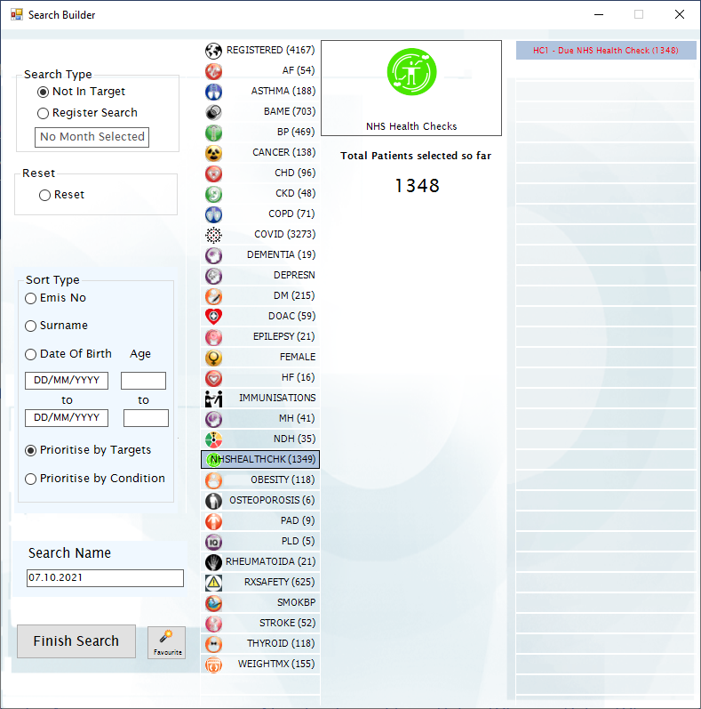

Step 1 – Importing the prebuilt Advanced Searches file into EMIS.
This prebuilt search stores your NHS Health Check criteria.
It is found in our PatientChaseweb folder in the C: Drive>Program Data location.
It is bundled in with other searches in a file called PatientChaseSearches.xml
Go to Population Reporting, select a folder to import into or create a new one called PatientChase.
Then click Import, select the 3 dots to the right and navigate to C>Program Data>PatientChaseweb.
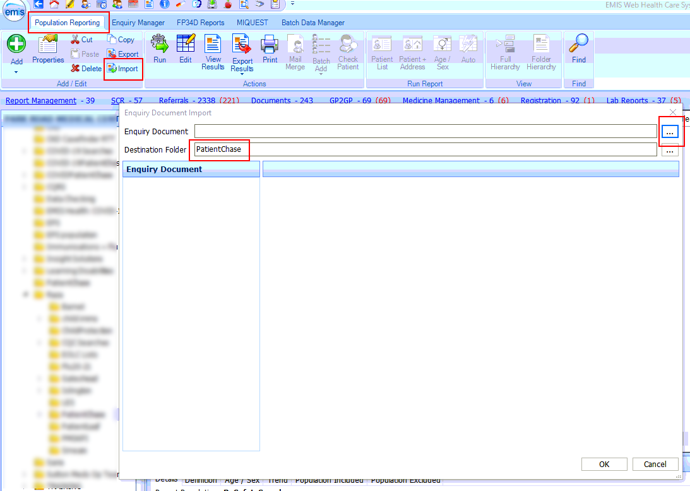

Within this folder select the file called PatientChaseSearches.xml. Click Open.
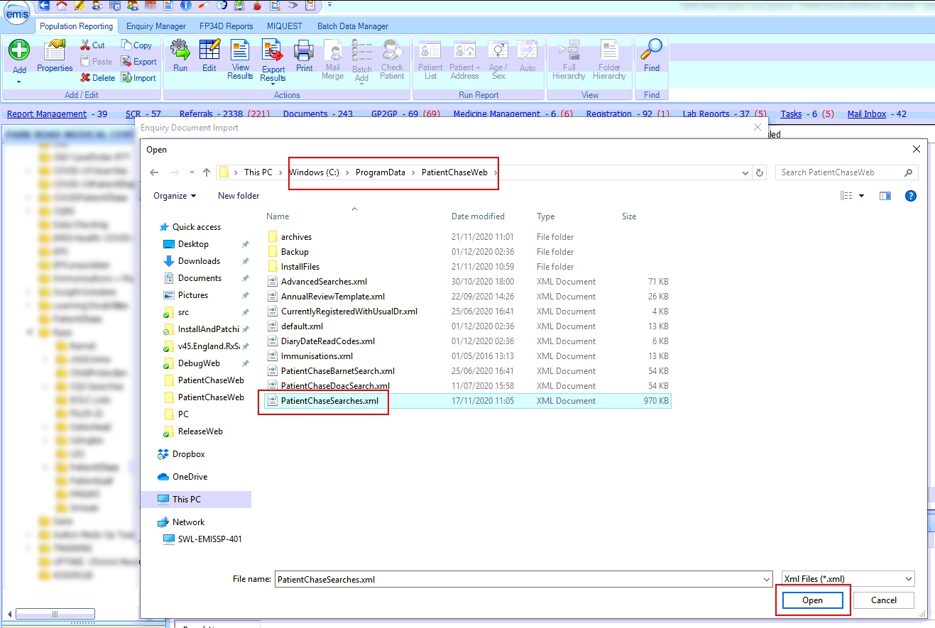
NB It is good practice to reimport PatientChaseSearches.xml from time to time to ensure that you are you using the latest version of the file.
Step 2 – Locate the Advanced Searches Auto Report.
After you complete step 1 above you will be presented with a number of folders. Open the folder called PatientChaseSearches and locate the Auto Report called ‘Advanced Searches’.
Run the Auto Report.
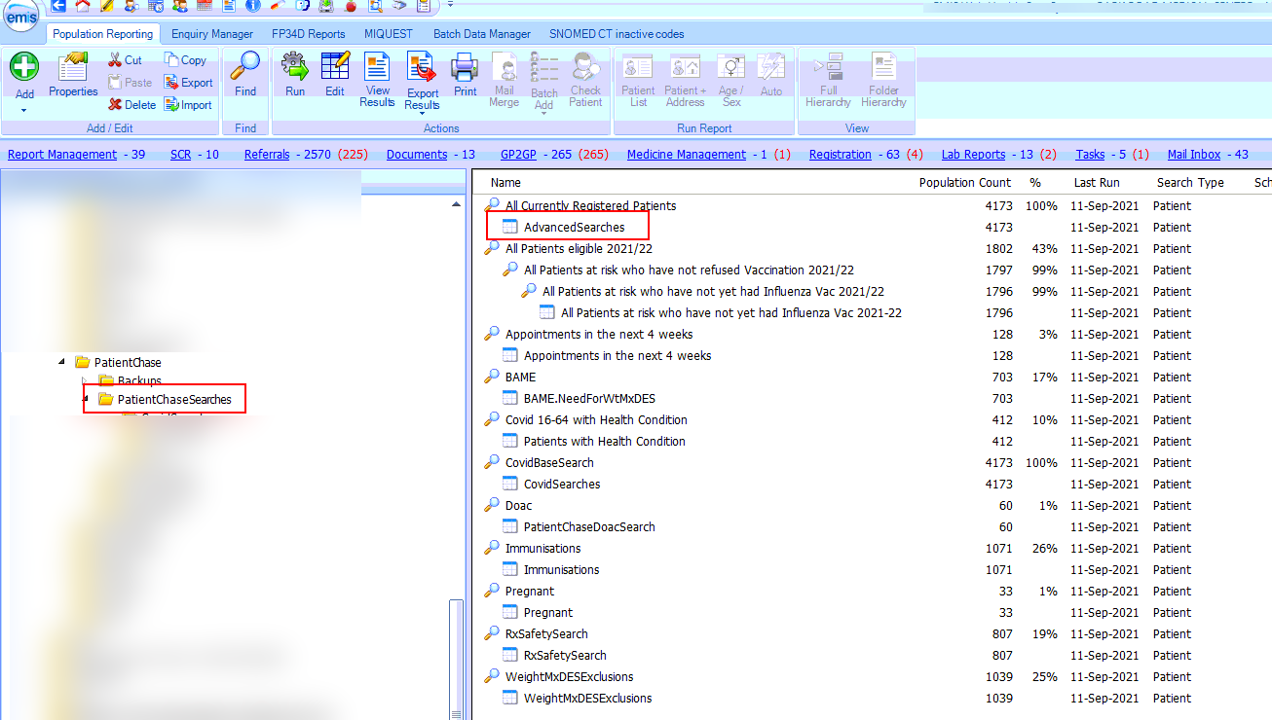

Step 3 - Exporting the results from EMIS.
Then click on View Results for the Advanced Searches Auto Report.
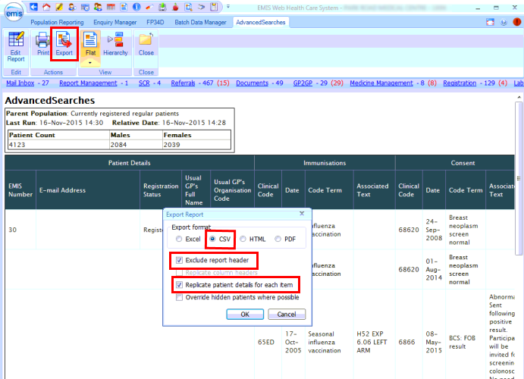
Click on Export then select the same export criteria as shown above.

Export to the desktop.
(NB. if you have previously created a folder where you export your EMIS searches to for synchronising with PatientChase then export to this location)
Do not change the name of the Auto Report.
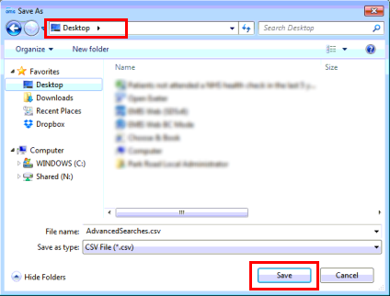

Step 4 – Open PatientChase and synchronise the data with PatientChase.

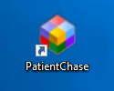
Make sure you are still logged into EMIS then double click the PatientChase icon on your desktop.

When PatientChase loads up, check first that you are running the latest version of PatientChase. This is indicated by a green tick near the top right of the screen:
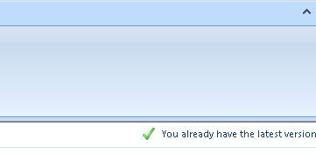
If you have a blue 'i' in place of the green tick, then restart PatientChase to load a patch update. From time to time we patch out updates and fixes so please look out for the green tick.
Next, click the EMIS Sync button.
When complete, PatientChase is loaded with your latest NHS Health Check data (as well as the default chronic disease data).
Note:
You must perform Steps 2 to 4 each new day you come to use new NHS Health Check data in PatientChase, whether you use the software daily, weekly or monthly.
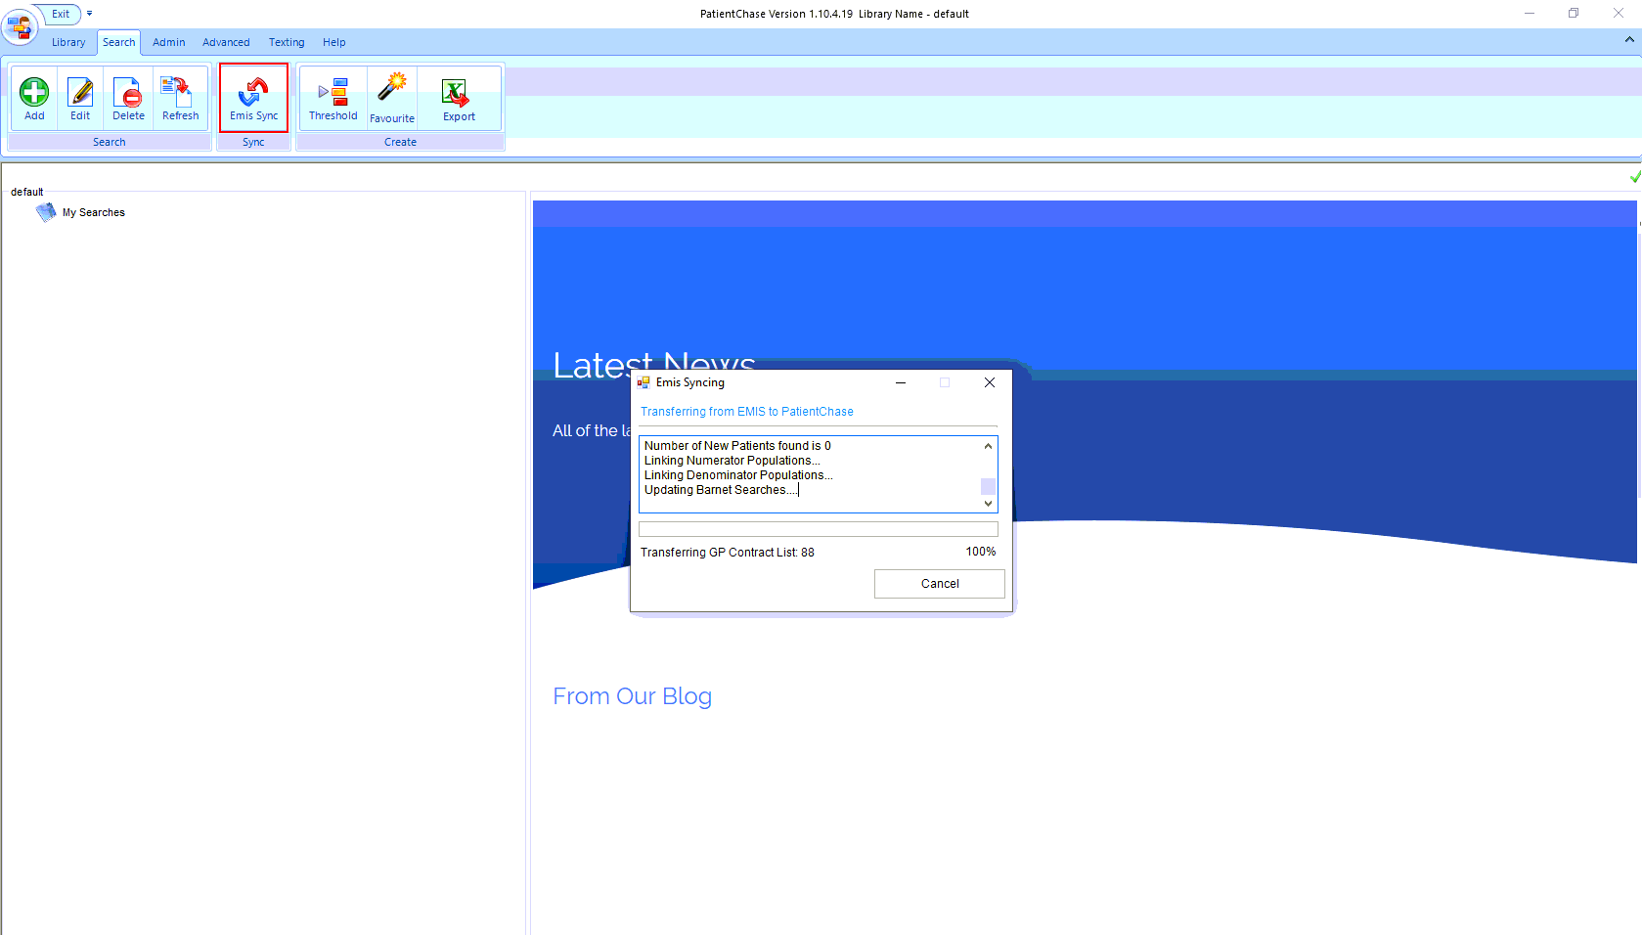

Example of use
Building a search of patients who are due an NHS Health Check and coding that they have been invited.
Click Add>Not in Target>NHSHEALTHCHK>Name Search>Finish Search
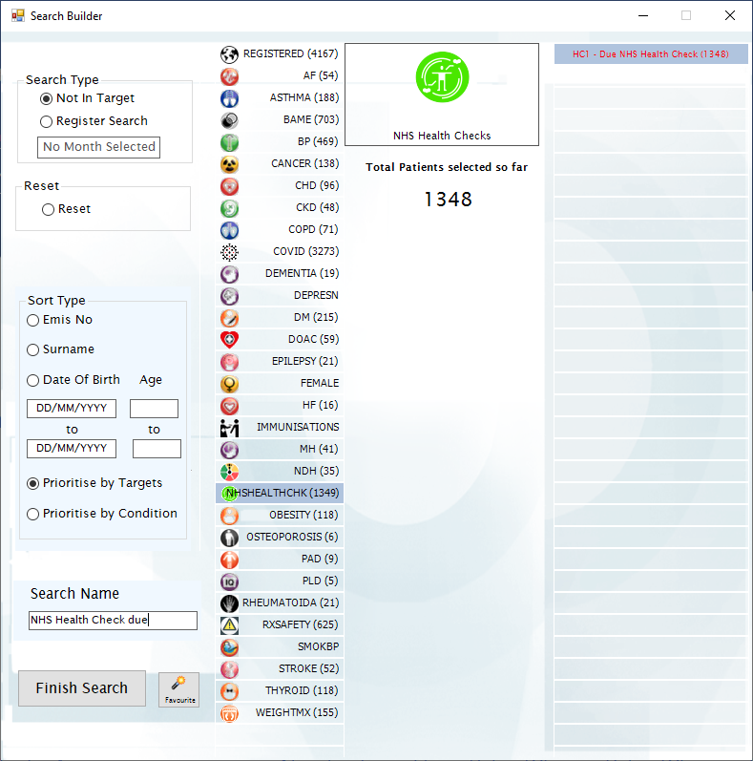
This will give you a list of those patients who are due an NHS Health Check.
Contact these patients in the usual manner.
Finally, use PatientChase to batch code into EMIS that you have contacted these patients. When you ‘insert into EMIS’ PatientChase will automatically know which code to enter.
You can combine NHS Health Check patients with other chronic diseases if you so wish.

