Using PatientChase to target PCN DES BP patients
In this section you will be shown how to:
- Import PCN DES BP patient data from EMIS into PatientChase to ensure you have the very latest list of patients
- Run a search for hypertension diagnosis where blood pressure recording of ≥140/90mmHg

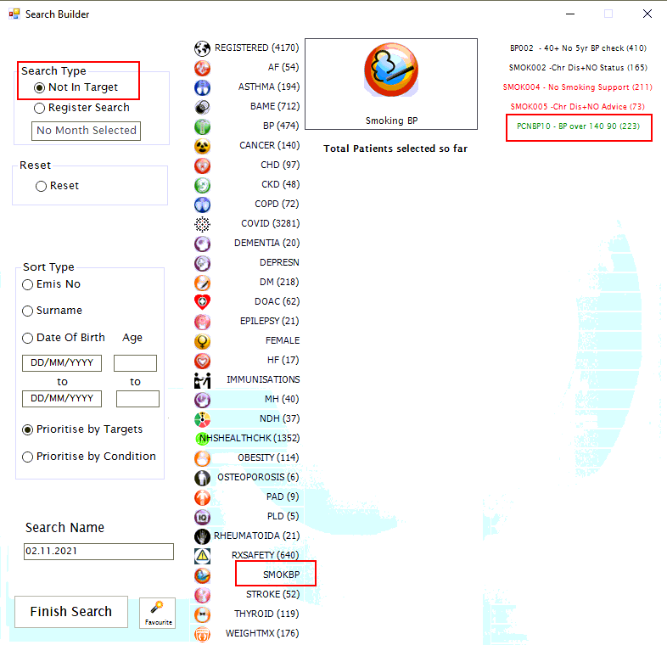

Step 1 – Importing the prebuilt Advanced Searches file into EMIS.
This prebuilt search stores your PCN DES BP criteria.
It is found in our PatientChaseweb folder in the C: Drive>Program Data location.
It is bundled in with other searches in a file called PatientChaseSearches.xml
Go to Population Reporting, select a folder to import into or create a new one called PatientChase.
Then click Import, select the 3 dots to the right and navigate to C>Program Data>PatientChaseweb.
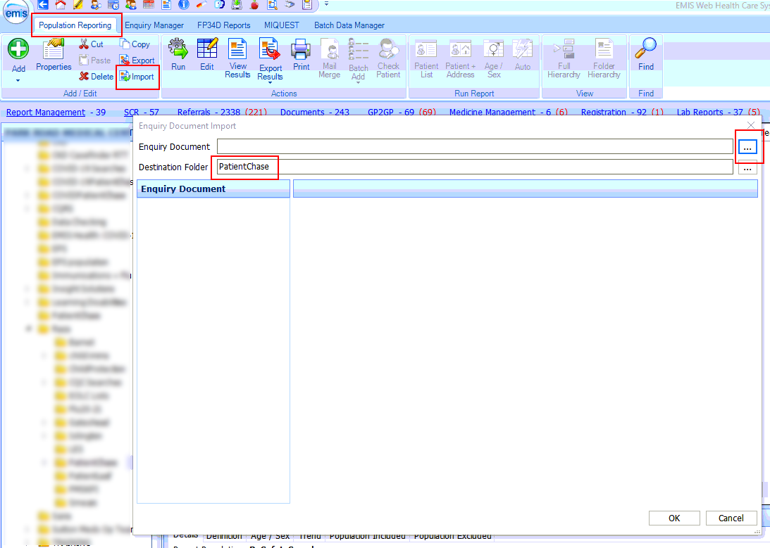

Within this folder select the file called PatientChaseSearches.xml. Click Open.
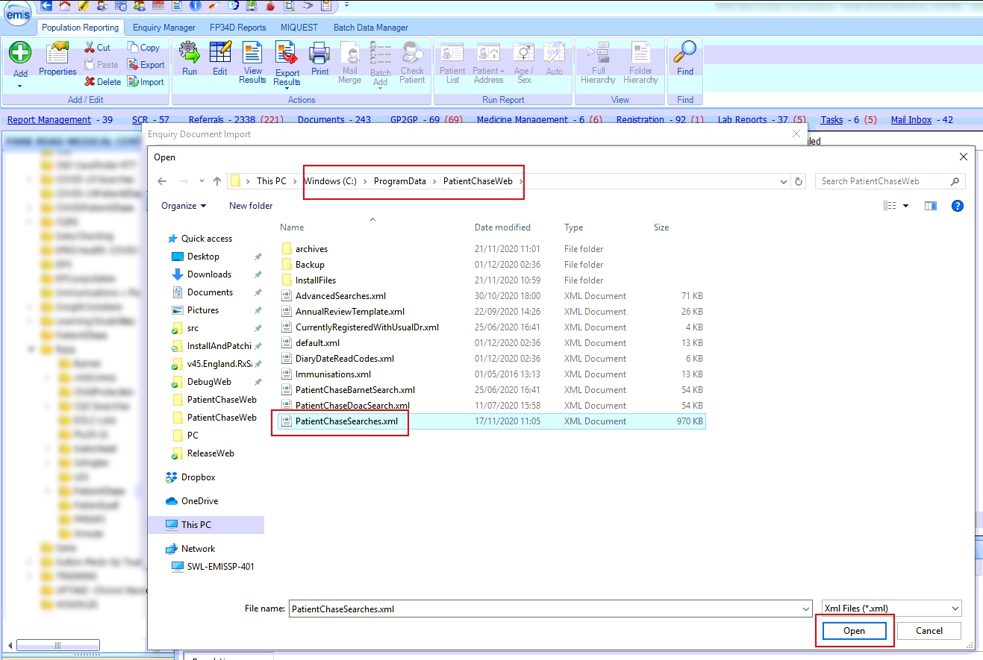
NB It is good practice to reimport PatientChaseSearches.xml from time to time to ensure that you are you using the latest version of the file.
Step 2 – Locate the Advanced Searches Auto Report.
After you complete step 1 above you will be presented with a number of folders. Open the folder called PatientChaseSearches and locate the Auto Report called ‘Advanced Searches’.
Run the Auto Report.
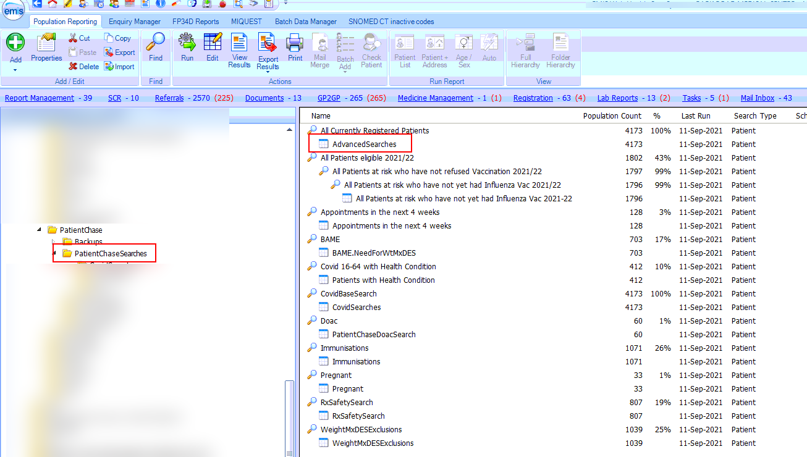

Step 3 - Exporting the results from EMIS.
Then click on View Results for the Advanced Searches Auto Report.
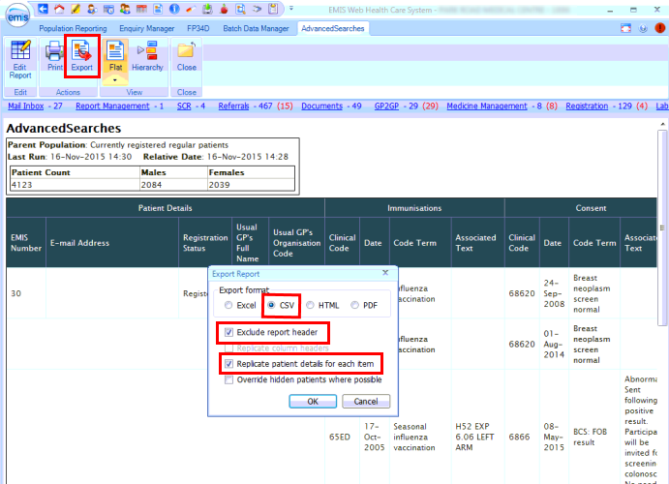
Click on Export then select the same export criteria as shown above.

Export to the desktop.
(NB. if you have previously created a folder where you export your EMIS searches to for synchronising with PatientChase then export to this location)
Do not change the name of the Auto Report.
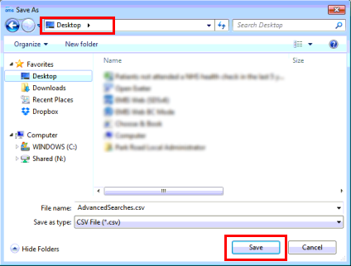

Step 4 – Open PatientChase and synchronise the data with PatientChase.

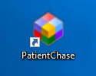
Make sure you are still logged into EMIS then double click the PatientChase icon on your desktop.

When PatientChase loads up, check first that you are running the latest version of PatientChase. This is indicated by a green tick near the top right of the screen:
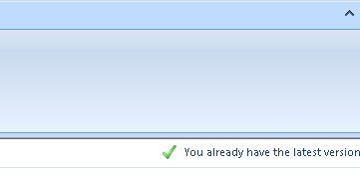
If you have a blue 'i' in place of the green tick, then restart PatientChase to load a patch update. From time to time we patch out updates and fixes so please look out for the green tick.
Next, click the EMIS Sync button.
When complete, PatientChase is loaded with your latest PCN DES BP data (as well as the default chronic disease data).
Note:
You must perform Steps 2 to 4 each new day you come to use new PCN DES BP data in PatientChase, whether you use the software daily, weekly or monthly.
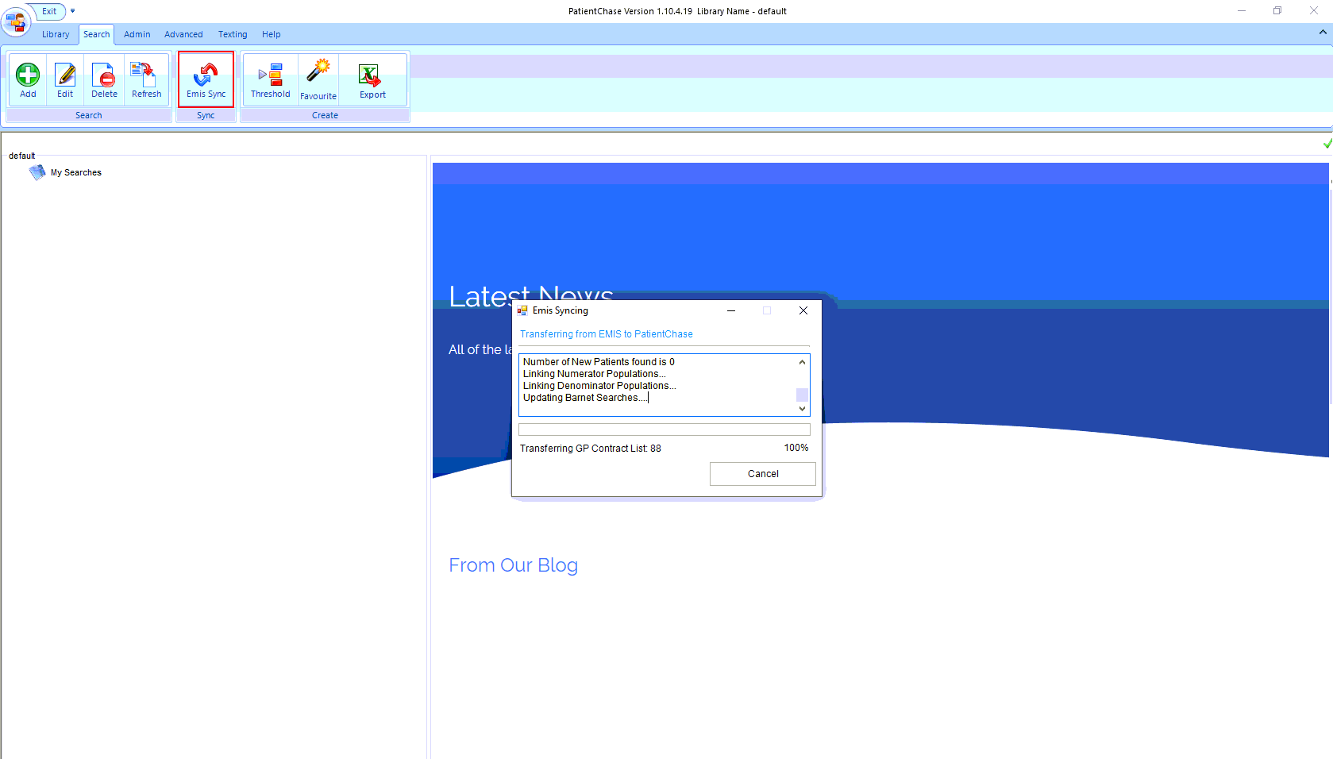

Identifying the patients
Click Add>Not in Target>SMOKBP>PCNBP10>Name Search>Finish Search

This will give you a list of those patients with hypertension diagnosis where blood pressure recording of ≥140/90mmHg
.
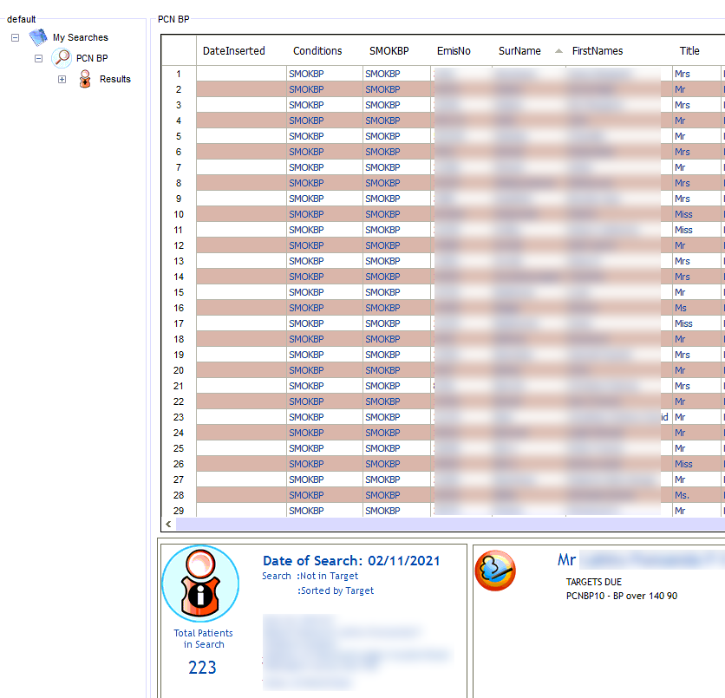
Contact these patients in the usual manner.
Remember, you can combine PCN DES BP patients with other PatientChase targets using our Search Builder if you so wish.

